**Exercise - Multi Charts using QlikView**

**Student Name: Student Id:**

**Date:**

# Please use the screenshots ONLY as a reference. The instructions have to be followed AS-IS.

# **Objective**

The objective of this exercise is to develop skills on how to visualize the data using QlikView tool.

This exercise focuses on visualizing data using multi maps aka Trellis maps. We will create these maps to track youth employment, income and expenditure trends over the years globally. Youth employment, income, and expenditure are key factors in identifying new markets for business.

**Prerequisite:** Install QlikView Personal Edition

In order to install the QlikView Personal Edition, please click on the below link.

<http://www.qlik.com/us/explore/products/qlikview/free-download>

You would be asked to login, fill the registration form and then download.

**Download the provided xlsx files from eLearning**

Following data files are provided:-

* Youth Employment Population File
* Youth Gross Income
* Youth Expenditure
* Youth Expenditure – Without Age

**Note:** All the charts should have a title preceded by the Student Name

1. **Visualize Youth Employment Population**

**Step 1: Create Visual Charts for Youth Employment Population**

**Step 1.1: Upload the youth employment population xlsx file onto QlikView**

Open QlikView, following screen will be visible. Click on the create button on the standard toolbar.

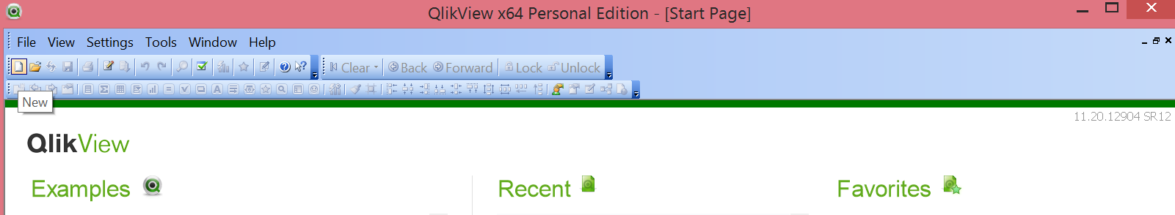

After clicking on create, following screen will appear:

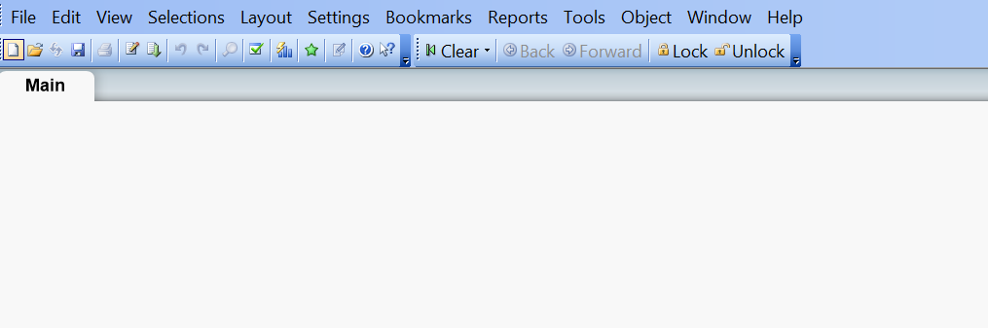

Add design toolbar, this would be needed to provide addition functionalities to your visualization.

Navigate to the following context menu option: **View -> Toolbars -> Design**

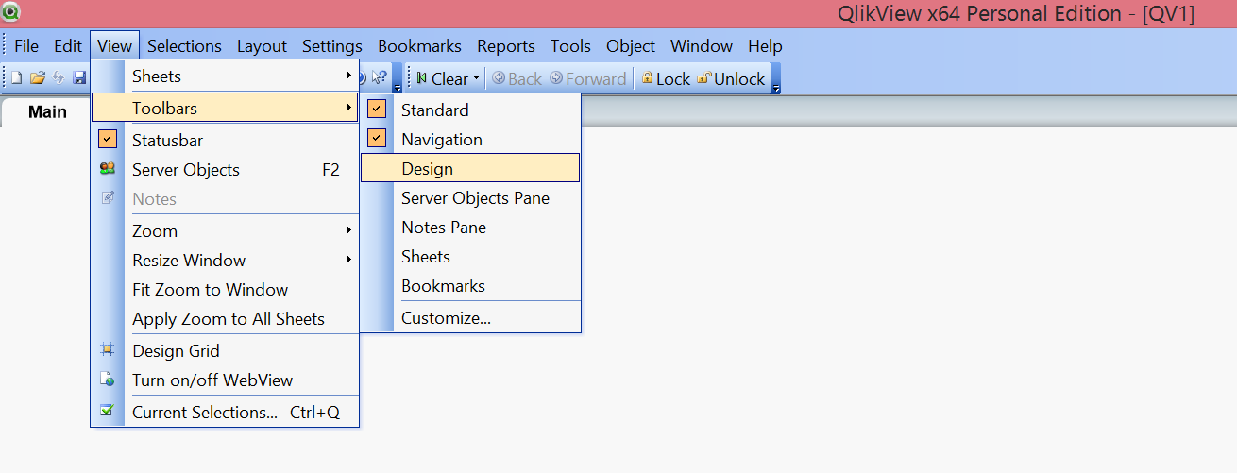

You should be able to view an additional toolbar, below the standard toolbar.

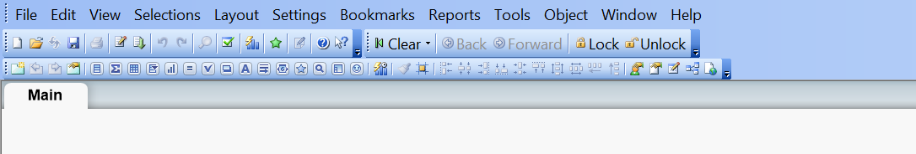

In order to **upload the data** into the QlikView, go to file menu, then click edit script

**File -> Edit Script**

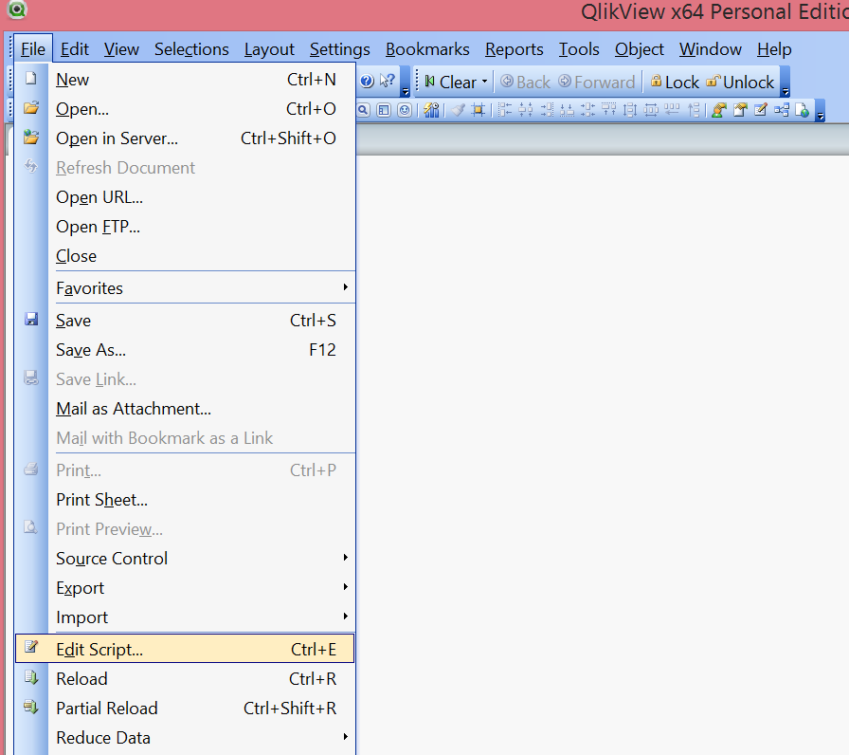

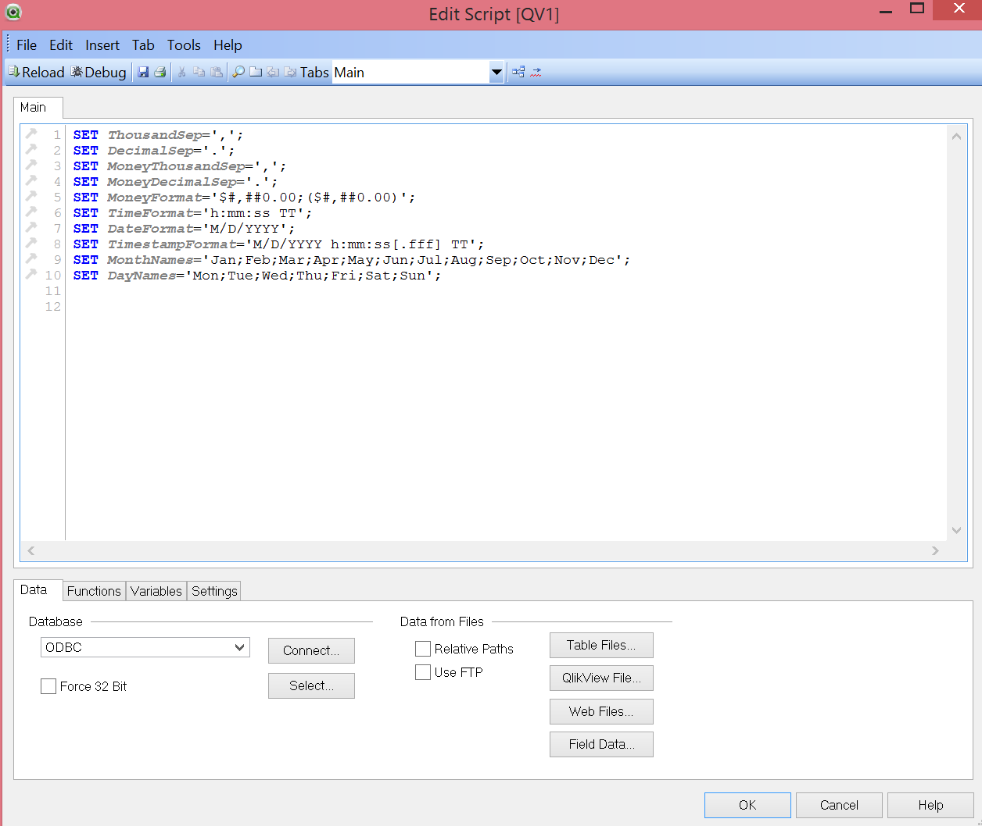

Now we need to upload the provided xlsx file. Click on the table files button in the bottom section of the edit script screen.

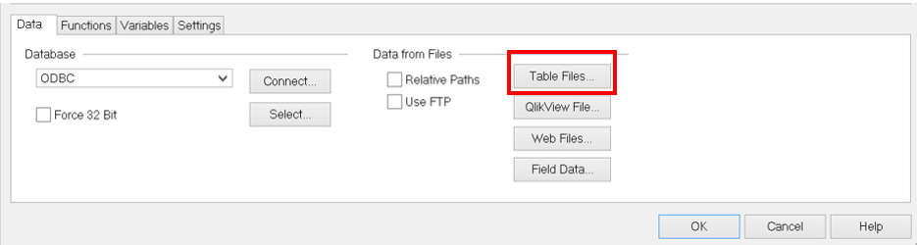

Select the path where the downloaded youth employment population file is placed and click on open.

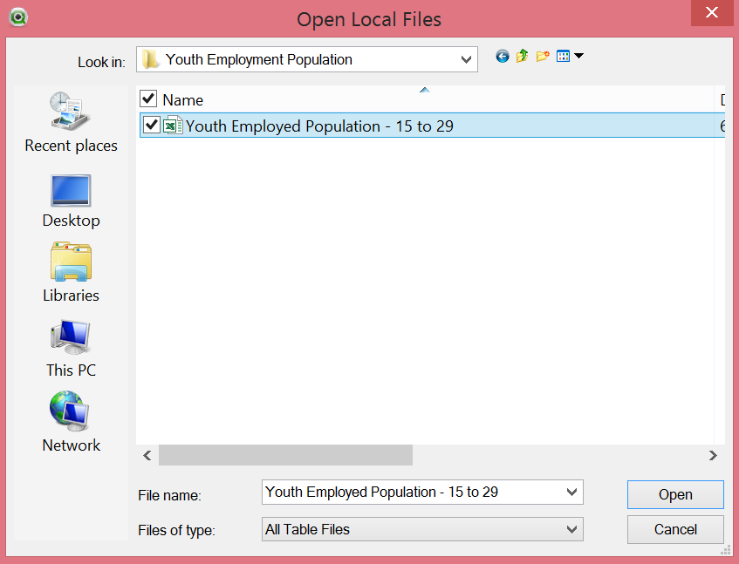

**File Wizard Type**: popup will appear, on the left select **xls** radio button and on the right click on the dropdown under **labels** and select **embedded labels. Click on next three times and then click finish.**

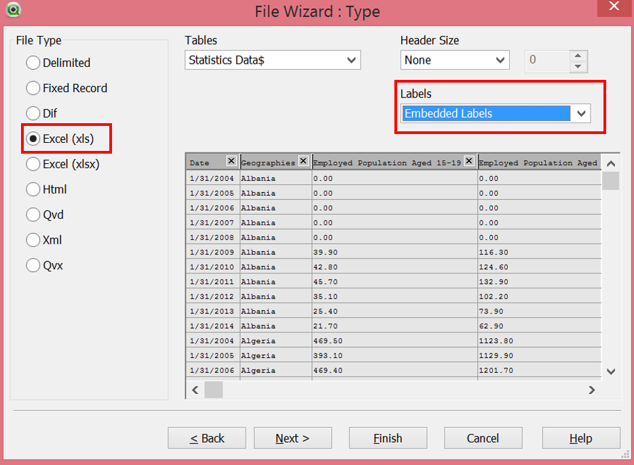 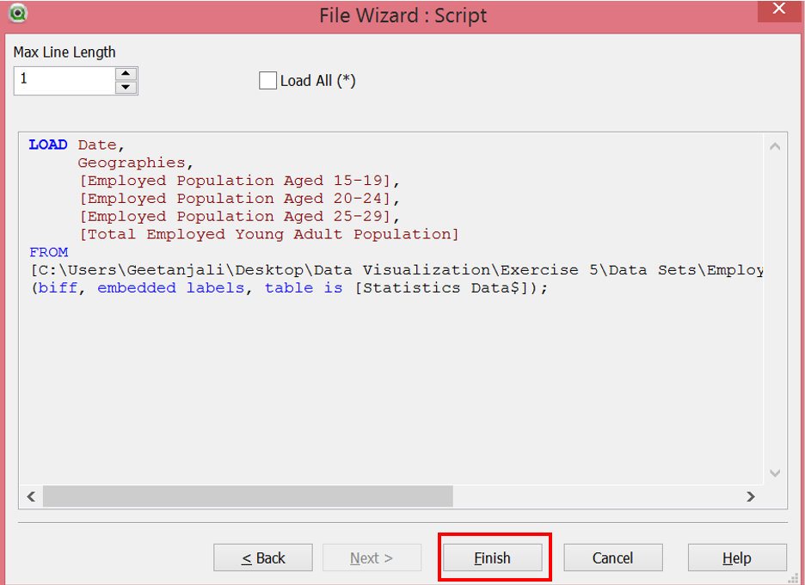

Query will be loaded in the edit script window.

**Note:** Inorder to display date in the year format, instead of **Date** maintain **Year(Date) as Year** as highlighted in the below screen shot and then click ok. Also since we will be using multiple data sets hence rename the **Geographies** field as **Geographies1**

Your output should look as below:-

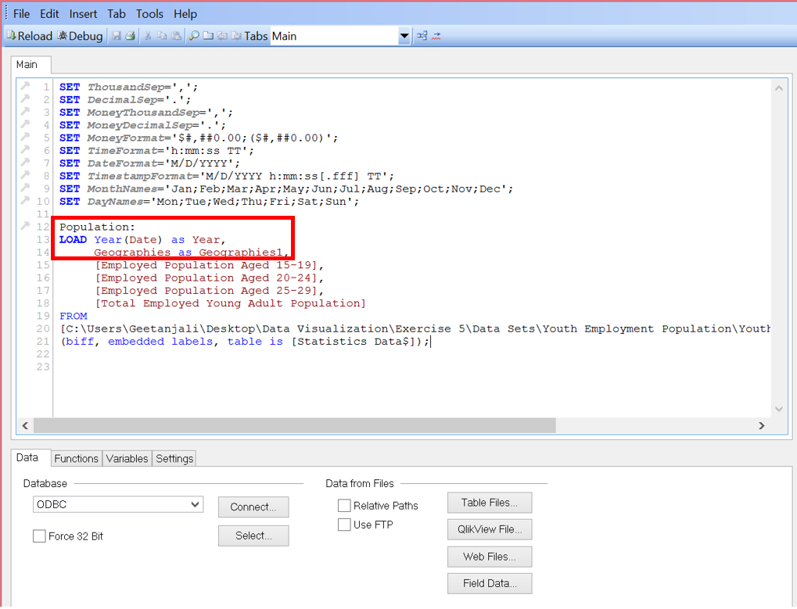

Click on Save icon in the **Edit Script window** ( create the file name as **F15_StudentName** ) and then click ok.

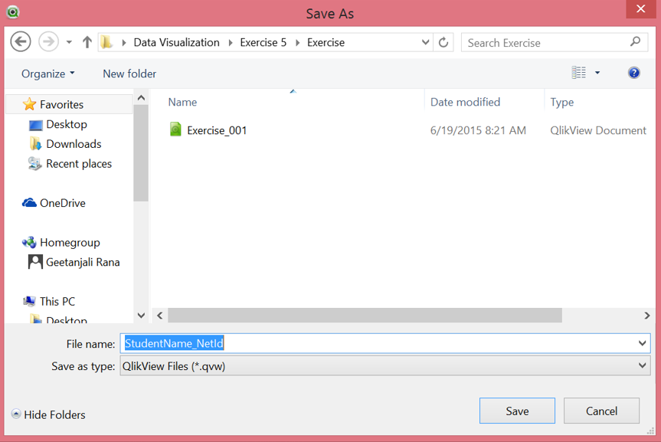

**Step 1.2: Reload data, uploaded in step 1.1.**

Everytime you make any changes to the file or Load a new file you need to reload the data. Data will not be loaded into QlikView until the reload button is clicked and so you would be able to view any data. This is one of the crucial steps while loading data QlikView.

You can reload the data using the following options.

1. Go to File -> Reload
2. Go to File -> Edit Script -> Reload ( Icon )
3. Reload using the icon in the standard toolbar

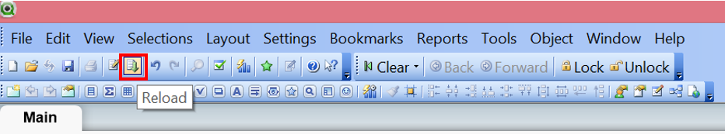

Sometime you might have to load the file again. In such a scenario delete the loaded query and then reload it by following step 2, Click on **reload** button on the standard toolbar.

Since we have uploaded the data, now we need to **click on the reload button** to complete the uploading process. Once you click on the reload button, the data uploading process will happen in the background. So you might not be able to view anything. In case you get any popup then just click ok.

**Step 1.3: Check Youth Employment Population Data**

1. Right click anywhere on the qlikview window.
   1. Select **New Sheet Object -> Table Box**

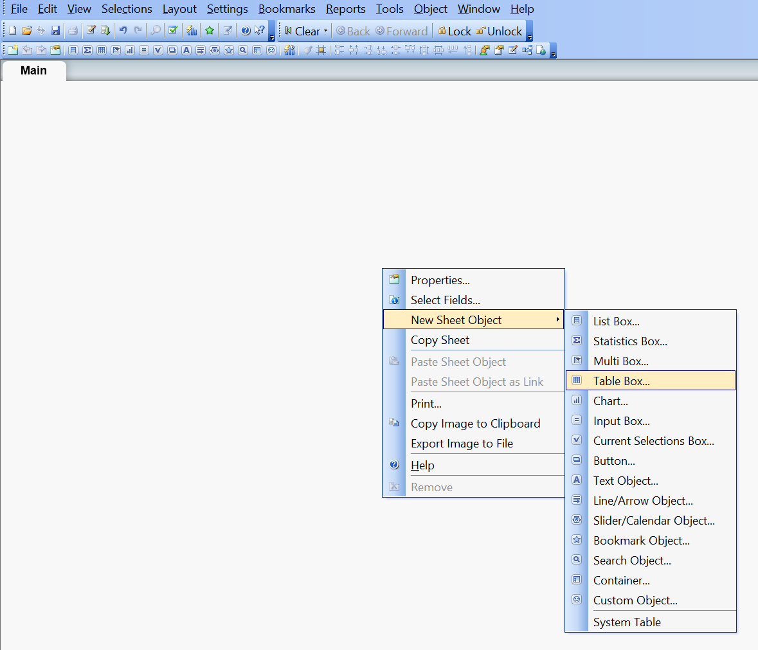

1. Following dialog box appears, select the field and click on Add All, then click on Load Order which orders the fields the way it is arranged in the xlsx file. After clicking on load order, your output should look as highlighted below.

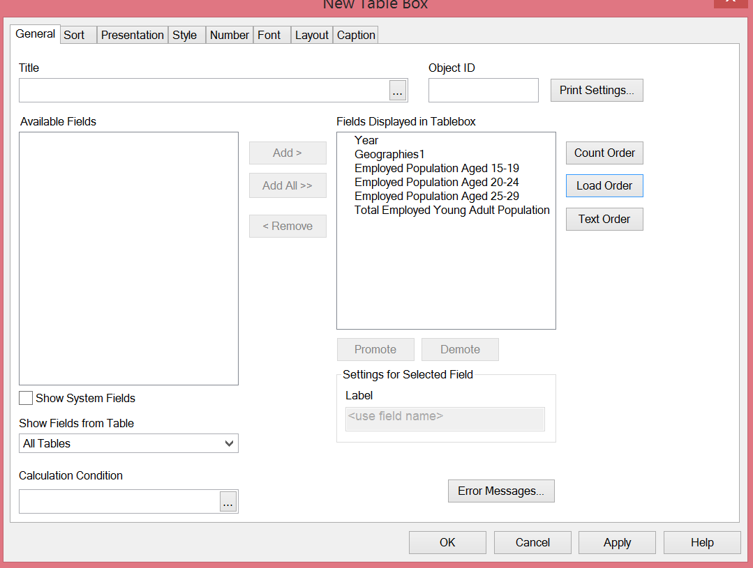

1. Click on apply and then click ok. Check whether your table is displaying the values or not. In case the table does not display the values then reload the data again.

Your output should look as below:-

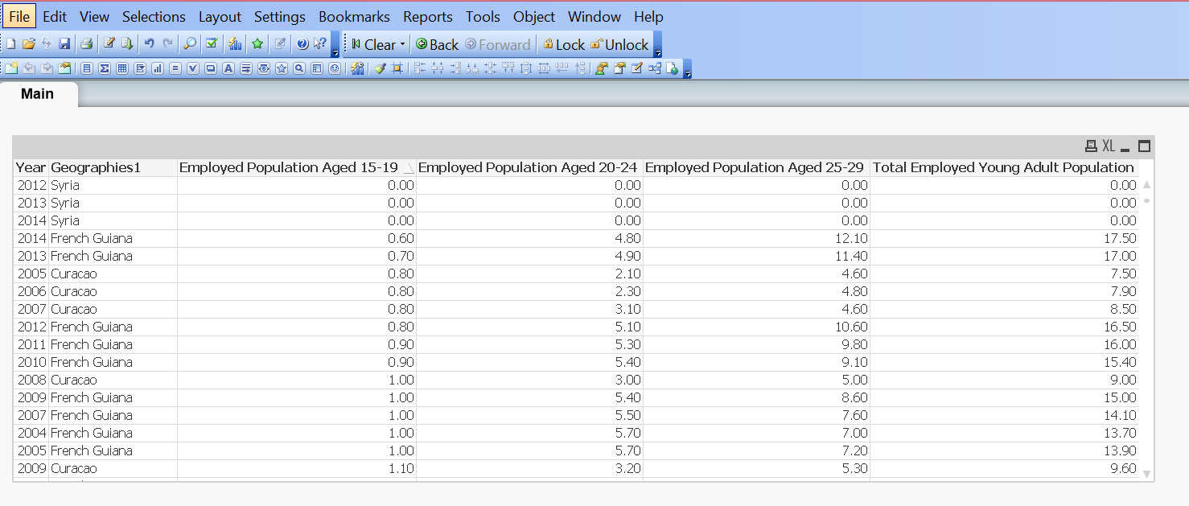

1. After adding the table, save the QlikView file by clicking on the save icon on the standard toolbar.

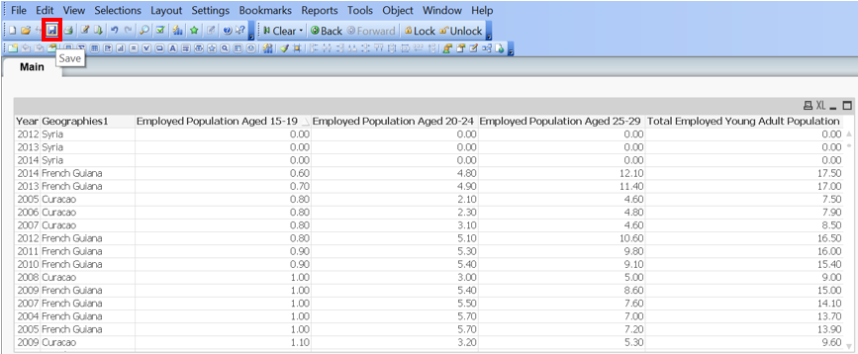

**Step 1.4: Add new sheet**

Click on Add Sheet icon in the QlikView window. By doing this a new sheet will be created beside the main sheet.

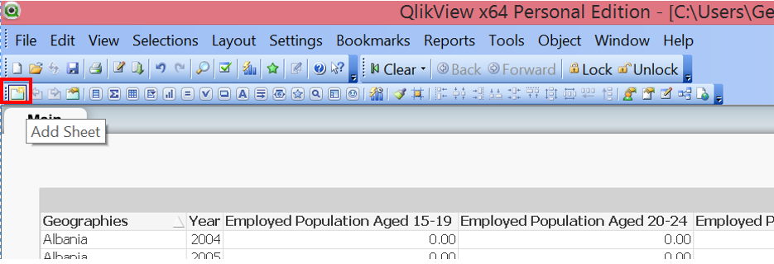

**Maintain sheet title**: Right click on the sheet name and click on **sheet properties,** in the generals tabmaintain title as **‘Youth Employment Population’**. Click apply & then click ok.

**Step 1.5: Create a Trellis/Multi Chart for Youth Employment Population**

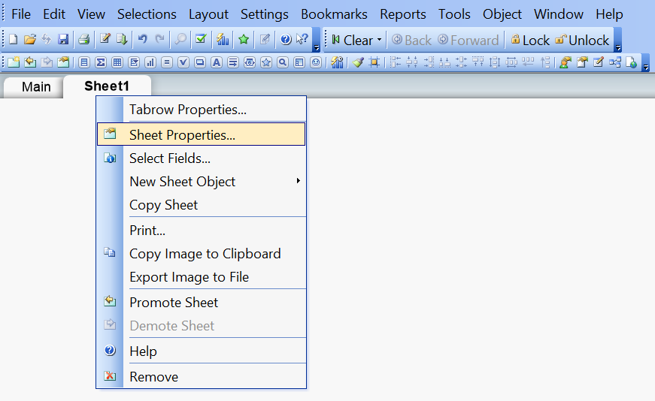

1. Create Filter for Geographies1 by creating a list box field/dimension

Click on the **List box** in the design toolbar as highlighted below.

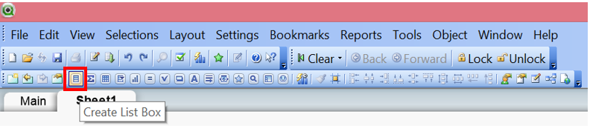

After on the create list box button, a popup appears maintain title & field which needs to be filtered (Geographies1) in the popup as highlighted below.

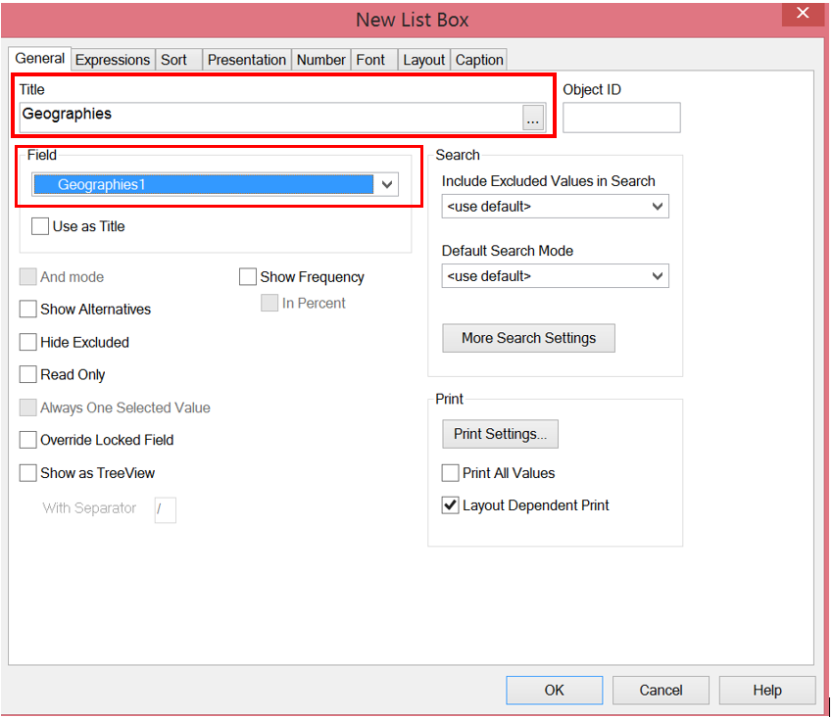

Now Click Ok. Your output should look as below

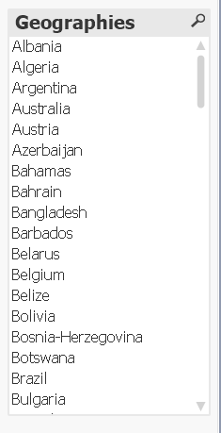

Place this filter in the top right corner of the sheet. This can be used to see trends of specific countries.

**Note**: In case you want to view the default selected entries in the chart then **right click on this sheet** and then select **clear** so that all the selections can be cleared. You can also enter the name of a specific geography on the top of this list box to select that entry.

1. In order to create a trellis chart, Right click anywhere on **Youth Employment Population** sheet.
   1. Select **New Sheet Object -> Chart**

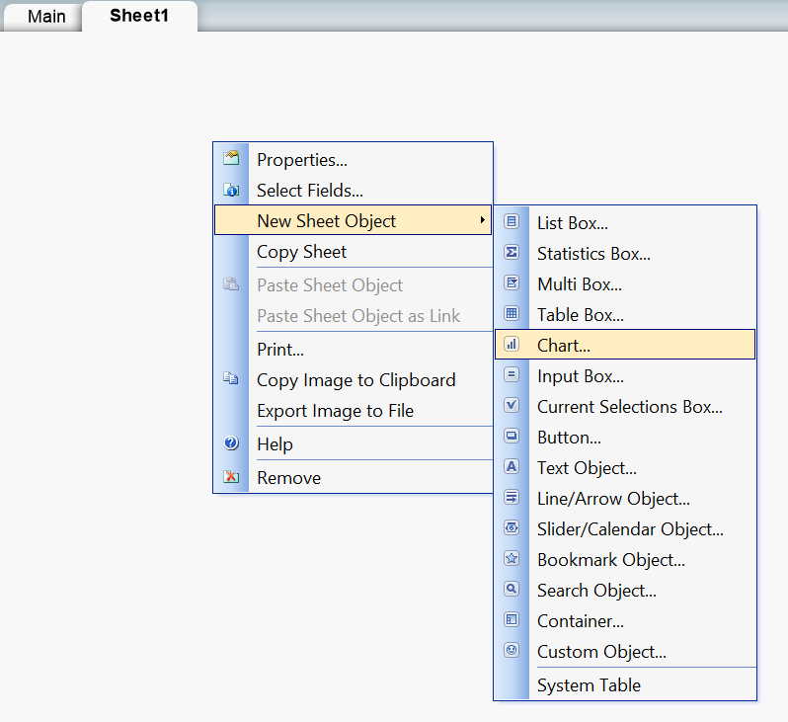

1. A dialog box appears, give a **title** to the sheet, & then select the **bar** **chart** as highlighted in below screenshot then click on next.

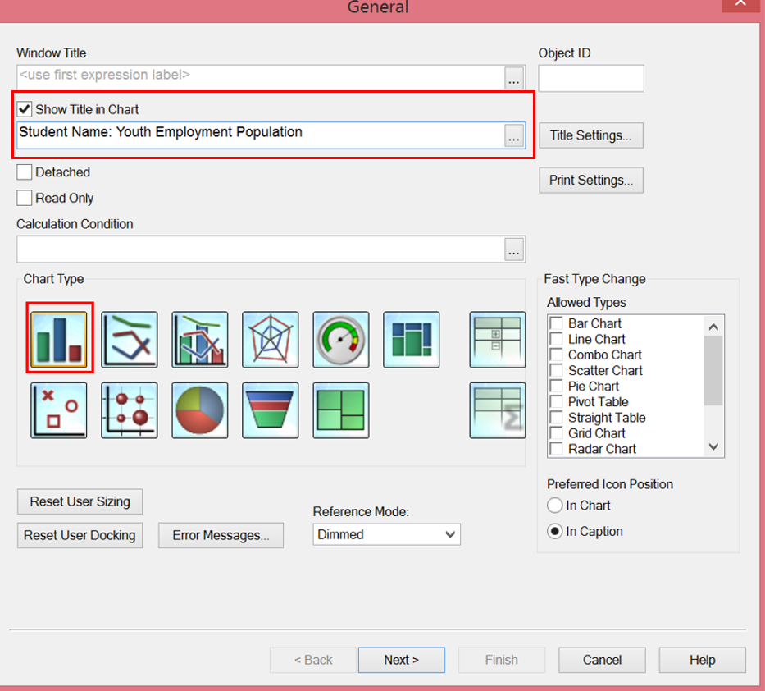

1. Under Dimensions Tab, add the following dimensions
   1. Select Geographies1, click add
      1. Check the checkbox **Suppress when value is Null**
      2. Maintain Label as **Geographies**
   2. Select Year, click add
      1. Check the checkbox **Suppress when value is Null**

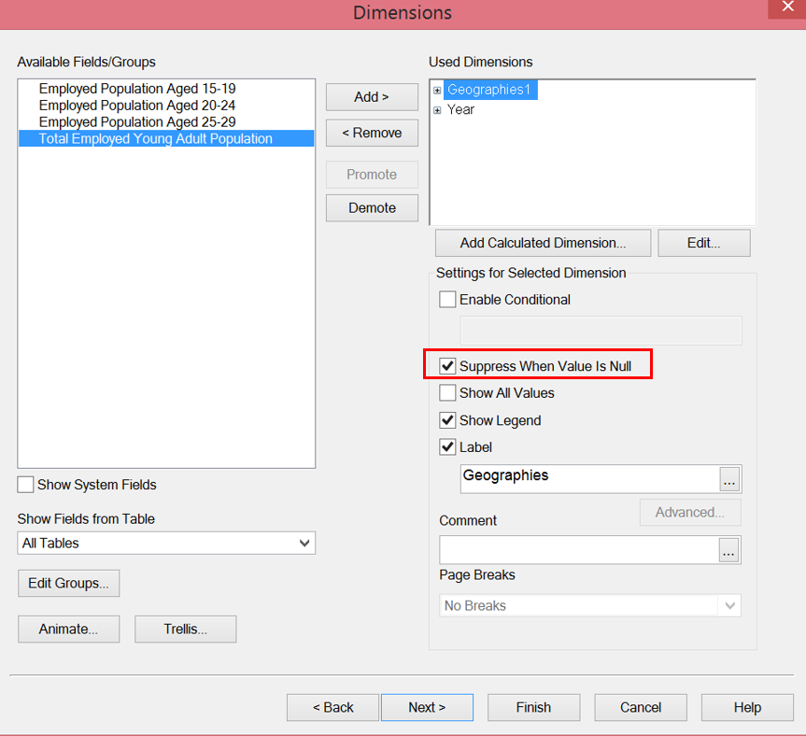

* 1. Click on Trellis button under dimensions tab, a popup will appear, maintain the following data in the same, this configures how your small multiples chart would be visible.

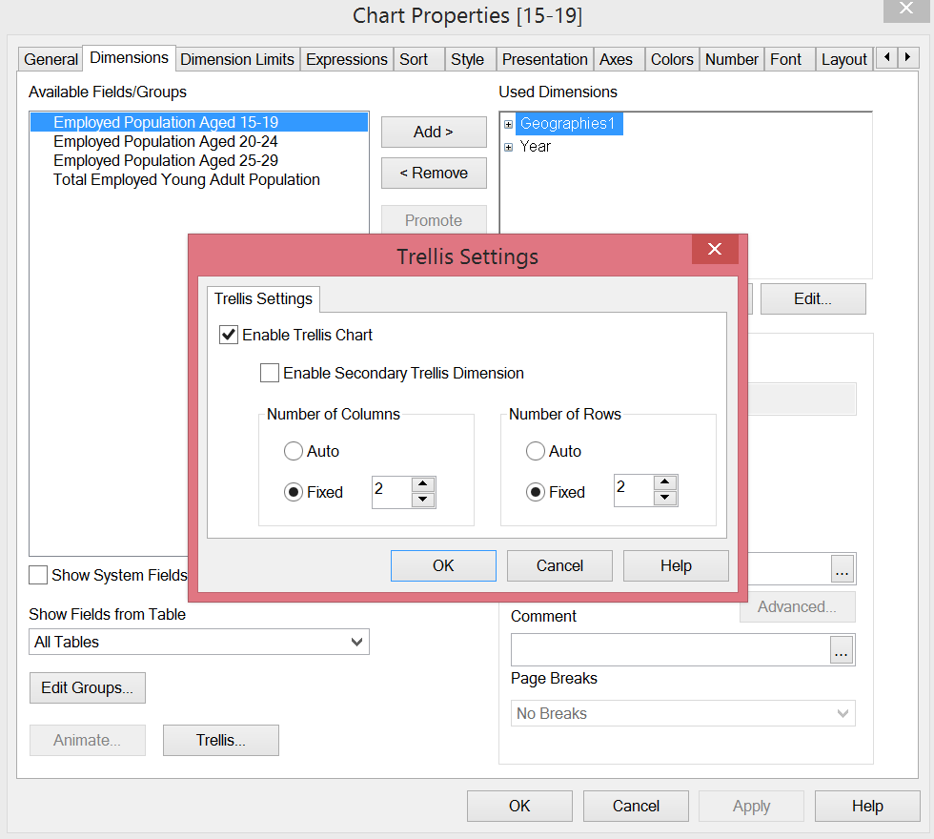

1. Click on next, a popup is displayed. Maintain the following measure/expression
   1. Aggregation: **Average**
   2. Field: **Employment Population Aged 15 – 19**
   3. Click on **Paste** button & then click Ok
   4. Label: **15-19**

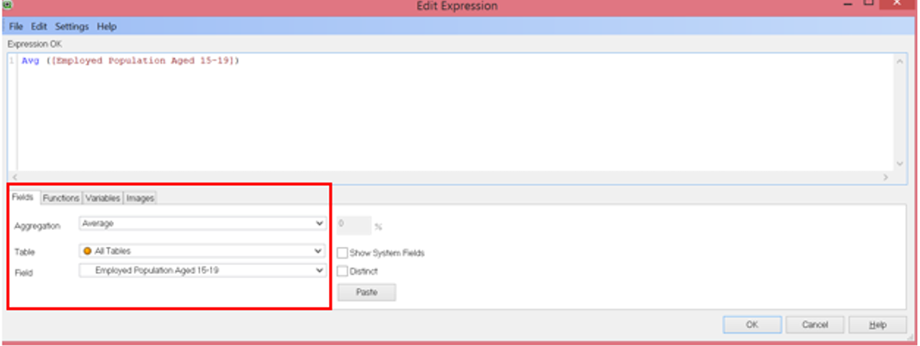

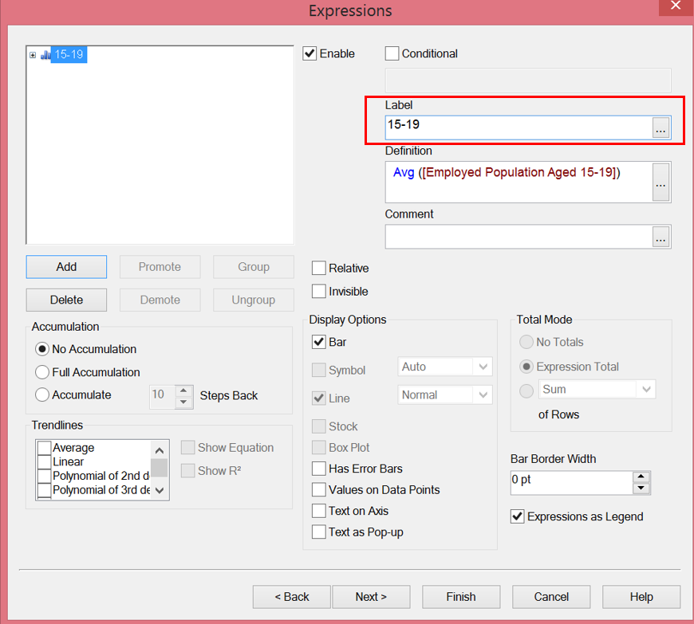

Click on add button in the expressions tab & follow the same steps as above to add following 2 more expressions:-

Maintain the following measure/expression:

1. Aggregation field -> Average
2. Field -> Employment Population Aged 20 – 24
3. Click on Paste & Click Ok
4. Label -> 20 - 24

Repeat steps 1 through 4 to add Field -> Employment Population Aged 25 – 29, also label it as “**25-29**”

Screen after this step should look as below:-

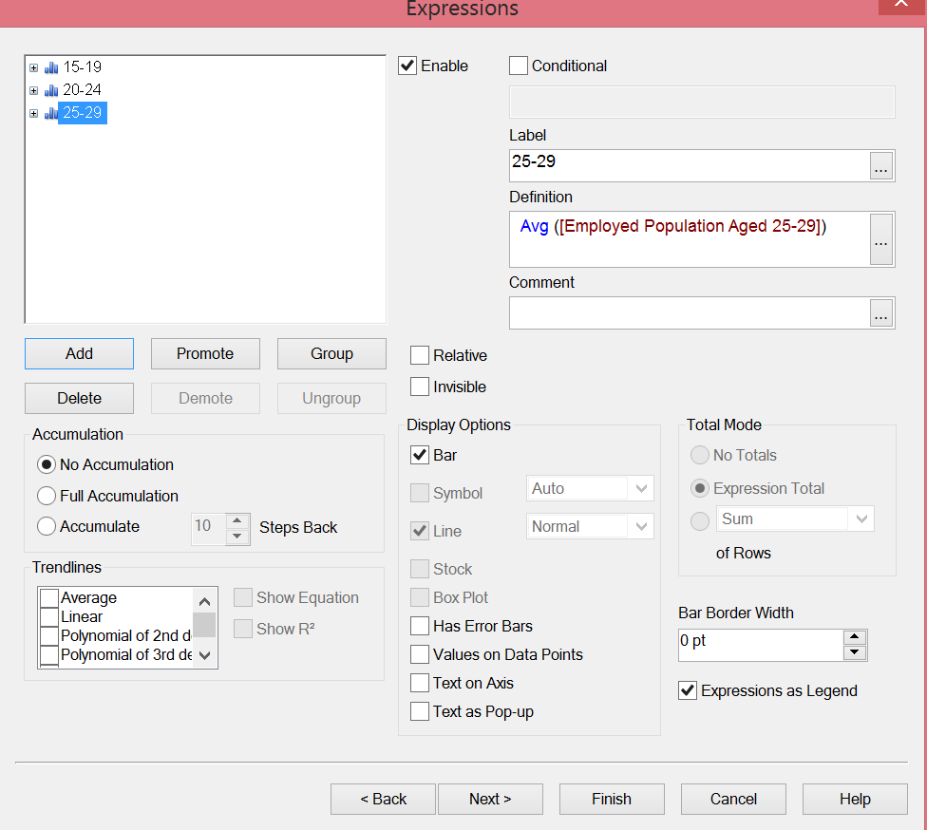

1. Keep clicking on the **next** button until you see the below screen then Uncheck the Caption checkbox (**Caption** Tab) and then click **finish**.

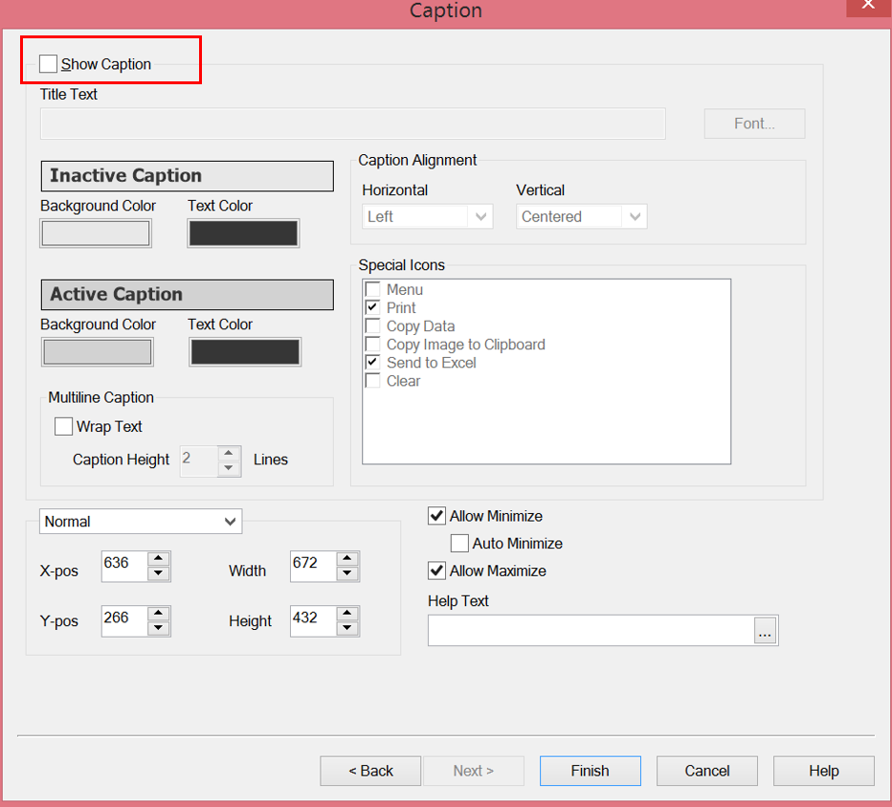

1. Since we have lots of data, the data displayed in the chart might not be very clear. So let’s filter the data. Here we are trying to display 10 geographies having the highest youth employment population

In order to do so, right click on the **chart** and select **properties**.

* 1. Under **Dimensions Limits** Tab,
     1. Select geographies
        1. Under Limits Section
           1. Check the “**Restrict which values are displayed using the first expression**” checkbox
           2. Select “**show only**” radio button,
           3. Select **Largest** from the drop down,
           4. Enter **10** in the text box.
        2. Under Options section
           1. Uncheck **Show Others** checkbox

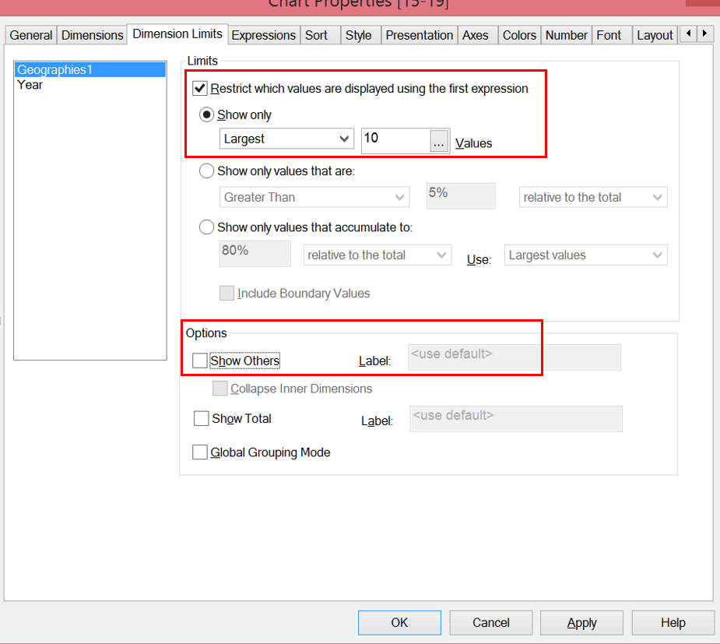

1. Go to the **Sort** Tab, Maintain the following entry as highlighted below

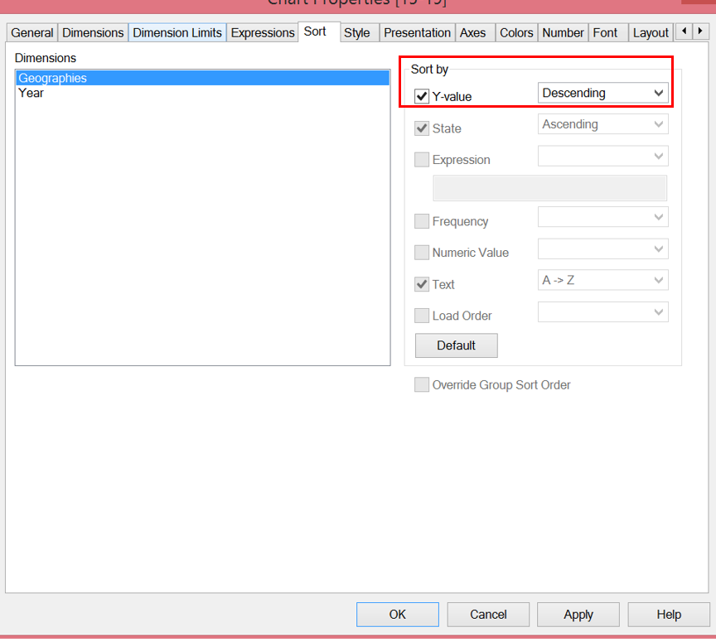

1. Click **Apply** & then click **Ok**. Expand the graph to cover less than half the area of the sheet, you can also view the largest 10 records, by scrolling down (Scroll bar on the right of the chart).
2. Save the QlikView file

**Step 1.6: Plot Youth Employment Population Trend**

1. Right click on the blank area of the sheet (Youth Employment Population sheet)
   1. **New Sheet Object -> Chart**
2. Under General Tab:
   1. Check “**Show title in chart”** checkbox:
   2. **Maintain Title**: Student Name: Youth Employment Population Trend
   3. **Chart Type**: Grid Chart

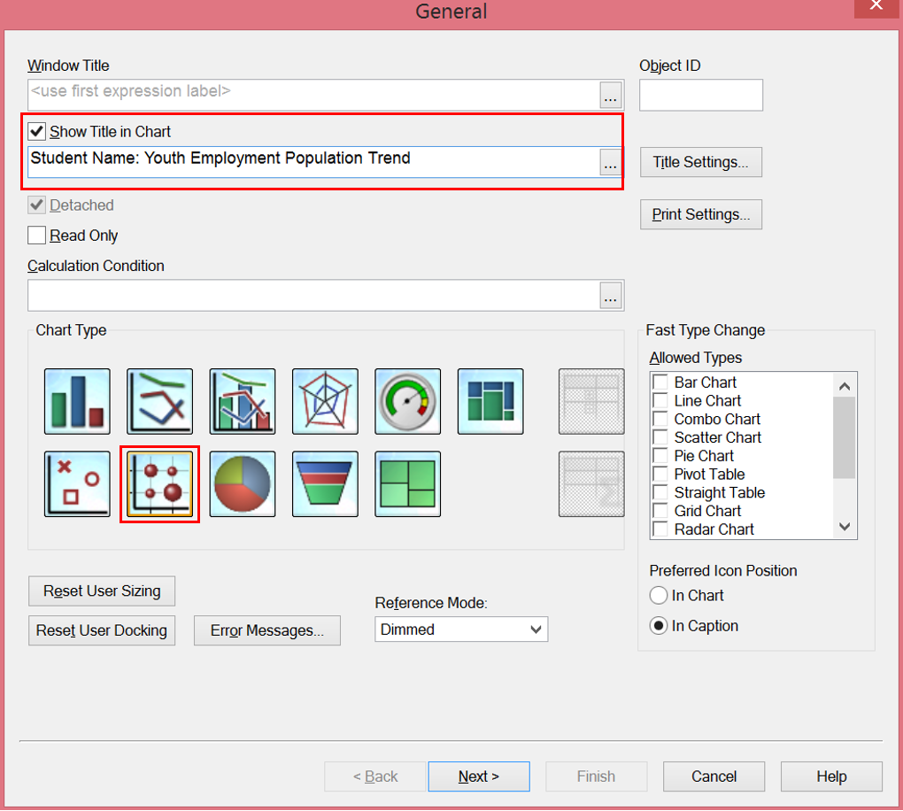

1. Click next, add following dimensions in used dimensions section by clicking Add button under dimensions tab.
2. Year
   1. Check “**Suppress When the value is Null’** checkbox
3. Geographies1
   1. Maintain Label as **Geographies**
   2. Check “**Suppress When the value is Null’** checkbox

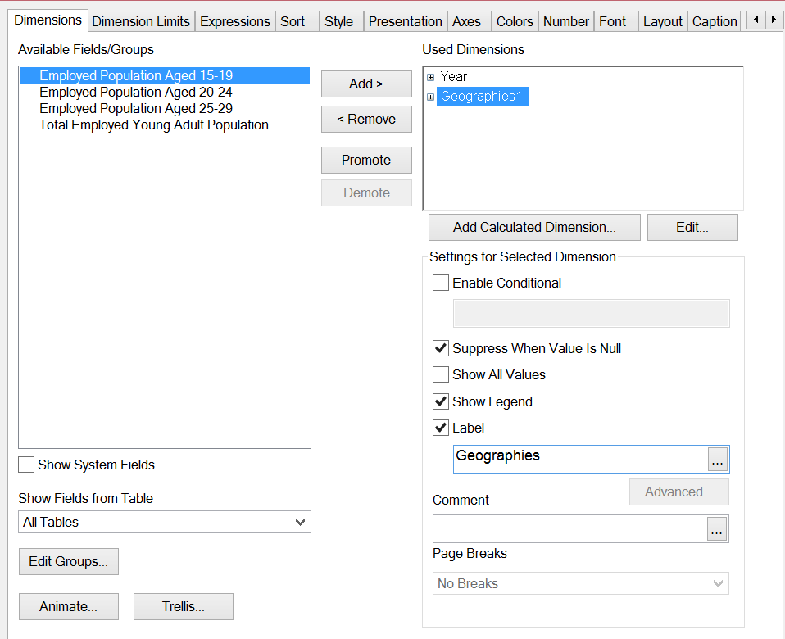

1. Click Next, add expression, following popup appears, maintain following under the **fields** **tab**:
   1. **Aggregation**: Average
   2. **Field** : Total Employed Young Adult Population
   3. Click Paste
   4. Click Ok

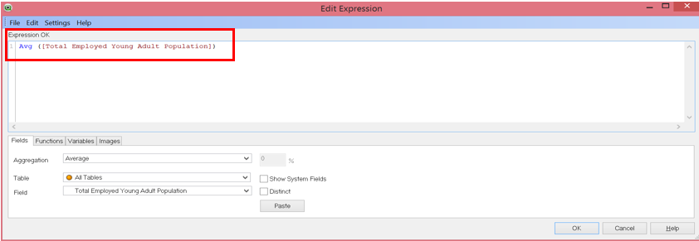

* 1. Change **Label** as Youth Employment Population

Your screen should look as below

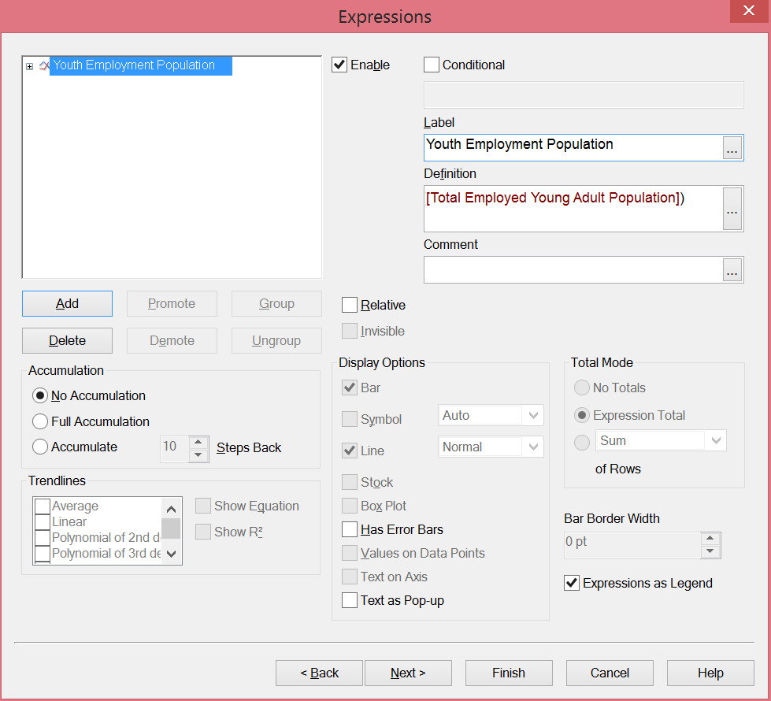

1. Go to Caption Tab (Hint: Last Window)
   1. Uncheck the “**Show Caption**” checkbox.
2. Click finish.
3. Filter the data to display the top 10 countries with highest youth population. In order to do so, right click on the graph, select **properties**
   1. Under **Dimensions Limits** Tab.
      1. Select the Geographies field
         1. Under **Limits** section
            1. Check “**Restrict which values are displayed using first expression**” checkbox
            2. Check **“Show only”** radio button,
            3. Select **Largest** from the drop down
            4. Enter value **10** in the text box
         2. Under **Options** section
            1. Uncheck **Show Others** checkbox

Your output should look as below:-

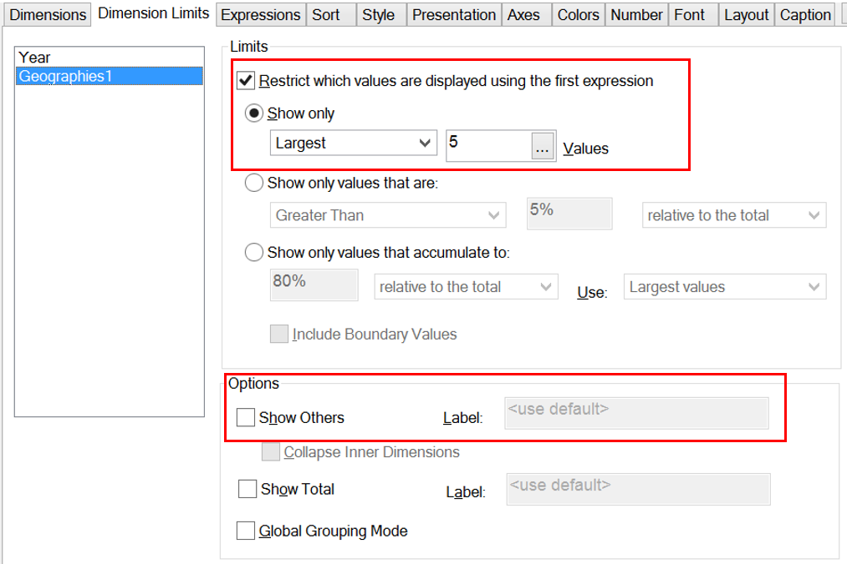

1. Click on Apply, and then click Ok. Expand the graph to view the data properly
2. Save the QlikView file

**Step 1.7 Add filter for Year**

Click on the slider icon as highlight below from the toolbar.

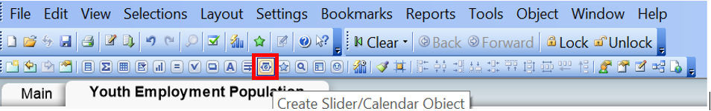

Following popup appears, maintain the following in the general tab:-

1. **Input Style**: Slider
2. **Field**: Year
3. **Mode**: Multi Value

Click on **Apply** and then click **Ok.**

Adjust the graphs and shift the slider to the top of the sheet.

You can also maintain color for the slider background and arrows in the presentation tab.

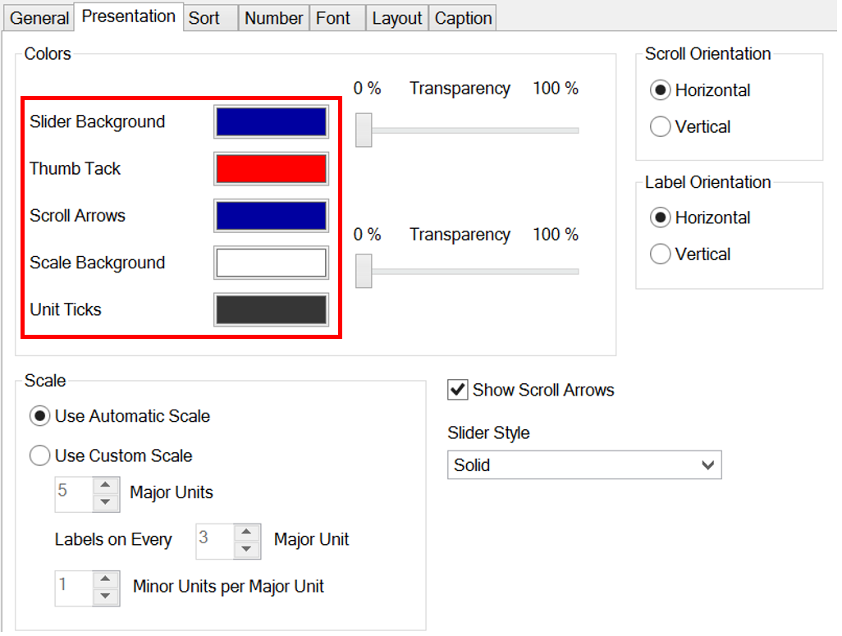

Slider output should look as below:

As per this screen shot, **Year** 2010 through 2012 is selected



**Questions:**

* 1. Paste the screenshot below of your sheet1 (Youth Employment Population)

**Answer**

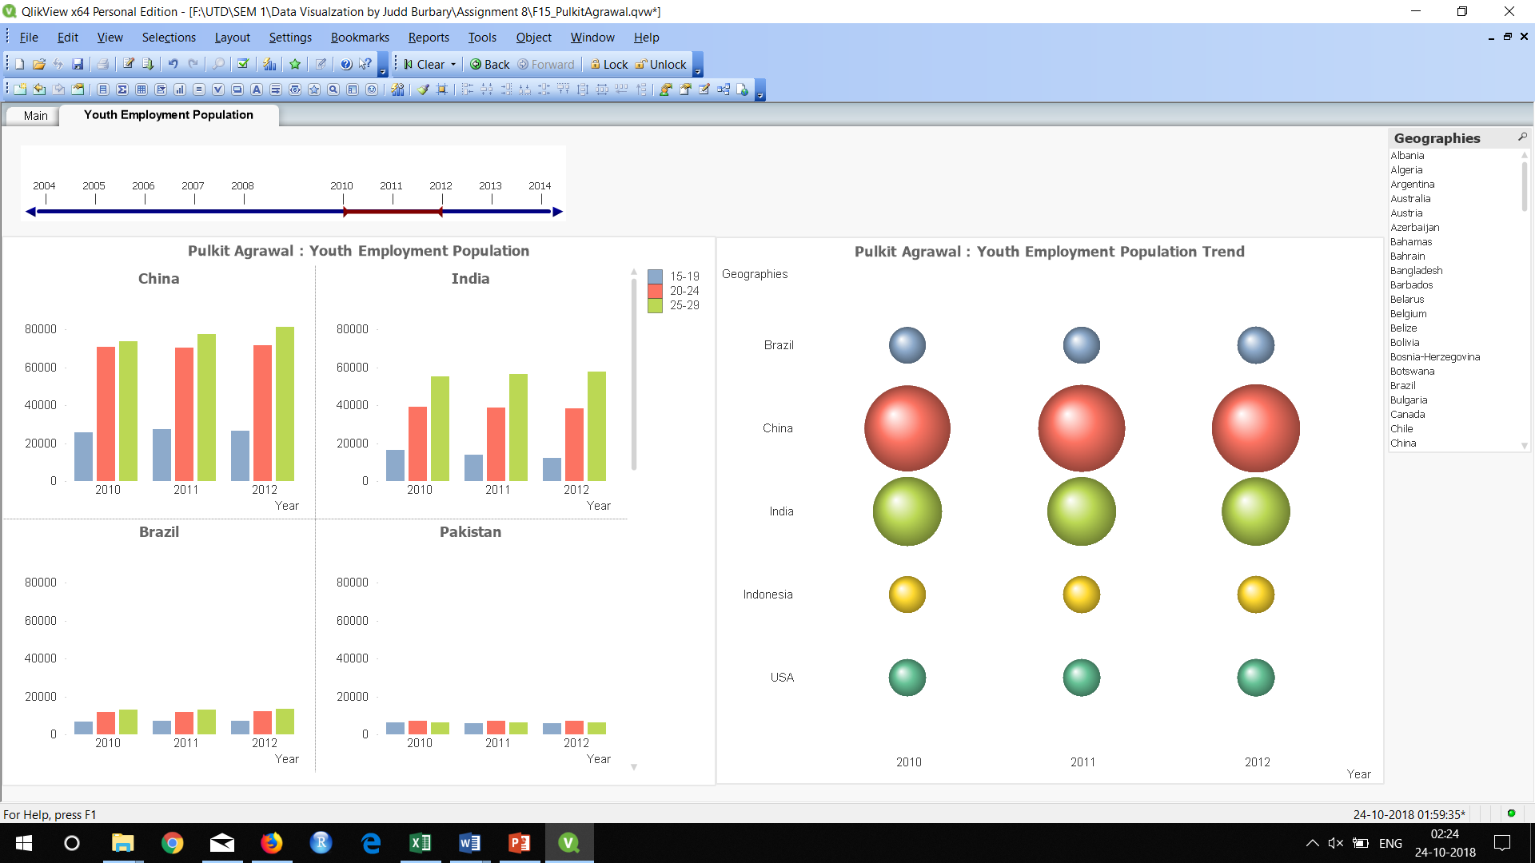

**Note: For all the below questions use the filter functionality provided to properly visualize the data**

* 1. Which is the country having the highest youth employment population between 2004 through 2014? Paste the screen shot of the Youth Employment Population sheet below.

**Answer China**

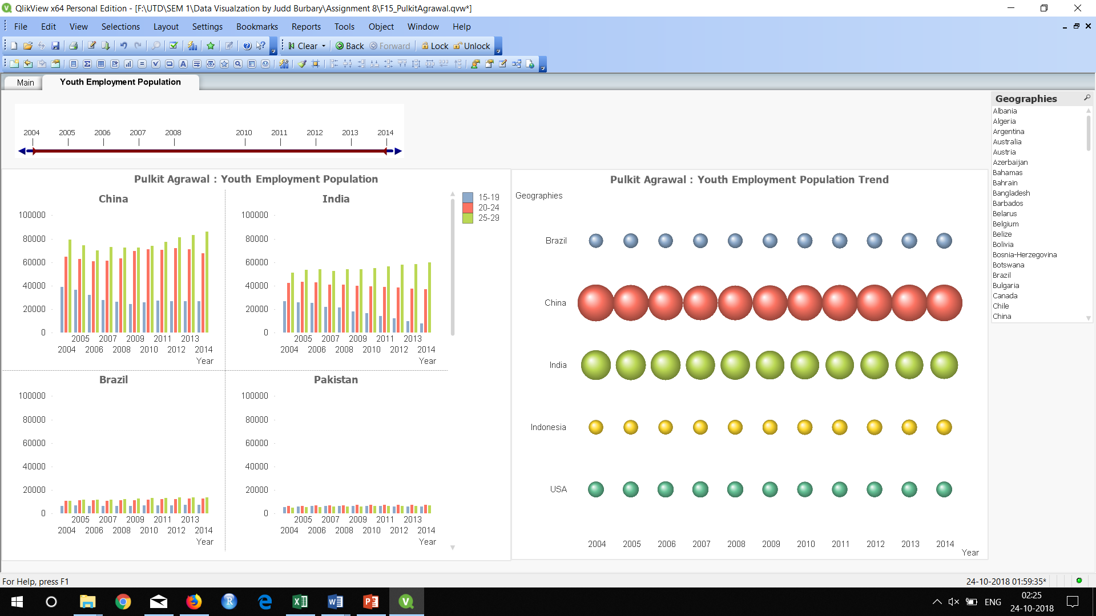

* 1. What is the trend between different age groups (15-19, 20-24, 25-29) do you notice in most of the countries from 2005 to 2014? What does the trend for Pakistan look like between these age groups?

**Answer**

1. **Visualize Youth Gross Income**

**Step 2: Create Charts for Youth Gross Income**

**Step 2.1: Add the Data Set for Youth Gross Income**

**Note:** We need to follow the same steps highlighted in **step 1 under Youth Employment Population.**

1. Go to File Menu -> Edit Script
2. Under Data tab, click on table files
3. Select the downloaded Youth Gross Income data set, then click open
4. Maintain the Labels as **Embedded Labels (As highlighted in red),** click next

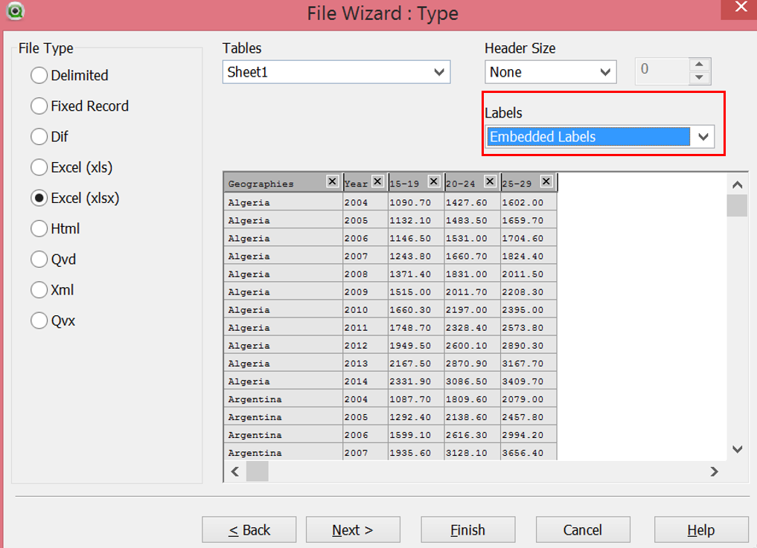

1. Click next thrice and then click finish
2. Rename the fields geographies and year as highlighted below and then click save

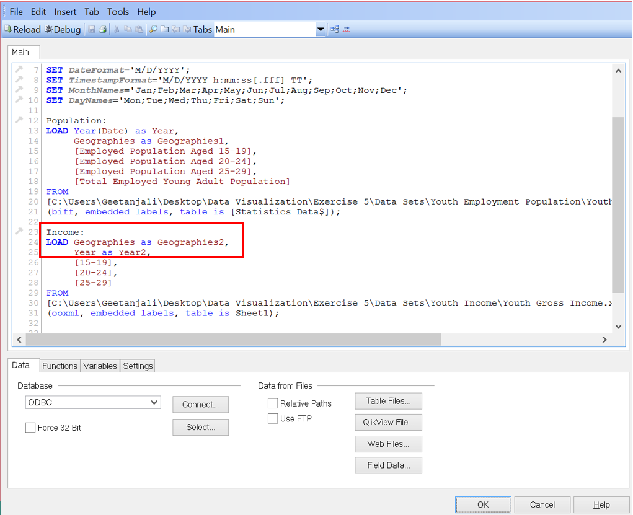

1. Click Ok 2 times. At this stage the data set is available in the QlikView.
2. Reload data by clicking on the **reload icon in edit script**

**Note**: For more details refer to section **1.2** under **Youth Employment Population section**

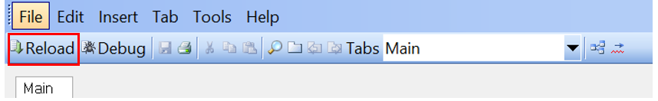

**Step 2.3: Create a New Sheet**

Follow the steps as highlighted in **step 1.4** under **Youth Employment Population section** to add a new sheet and rename the new sheet as **Youth Gross Income**

**Step 2.4: Create a Trellis or Multi Chart for Youth Gross Income**

1. Create Filter for field **Geography2** by adding list box

Refer to **step 1.5** under **Youth Employment Population**.

1. Right click anywhere inside **Youth Gross Income** sheet
   1. Select New Sheet Object -> Chart
2. In General tab, maintain **chart title** and select the chart type as **Bar char**t and then click next

Title: **Student Name: Youth Gross Income**

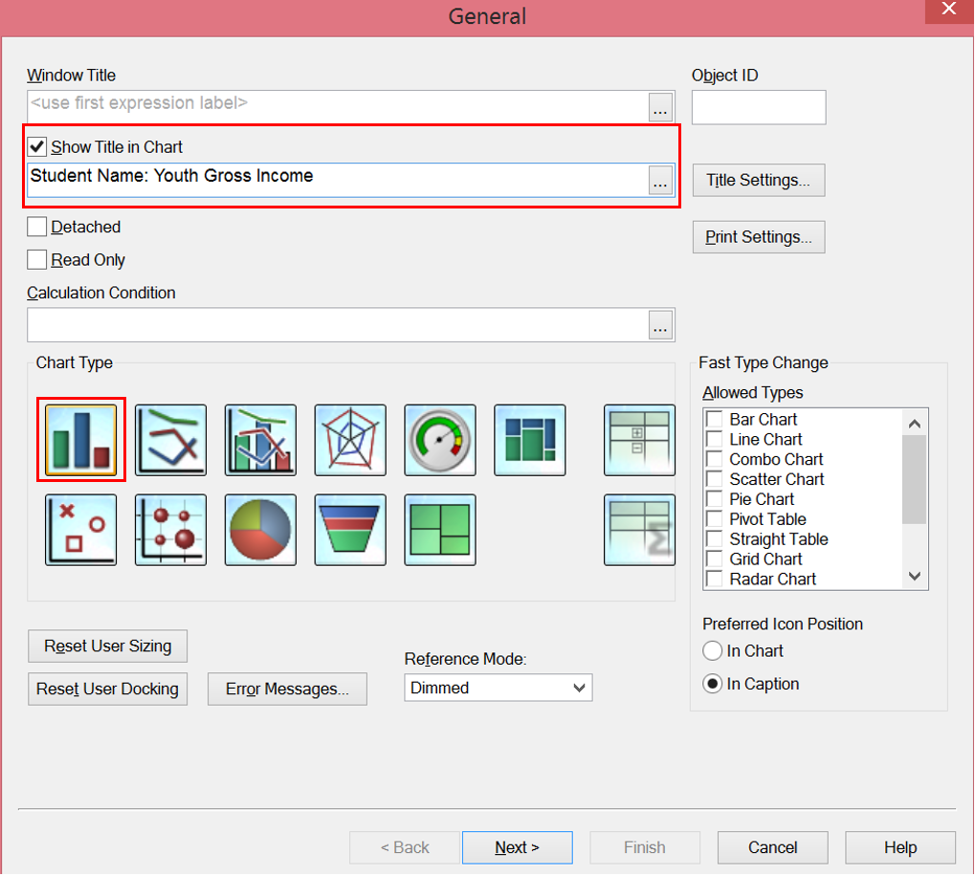

1. Maintain the Dimensions in the Dimensions Tab and then click next
   1. Add **Geographies2** into **Used Dimensions** section
      1. Check the checkbox “Suppress when value is Null”
      2. Maintain Label as **Geographies**
   2. Add **Year2** into **Used Dimensions** Section
      1. Check the checkbox “Suppress when value is Null”
      2. Maintain Label as **Year**
2. Click on Trellis button, a popup appears. Maintain the values in it as highlighted below

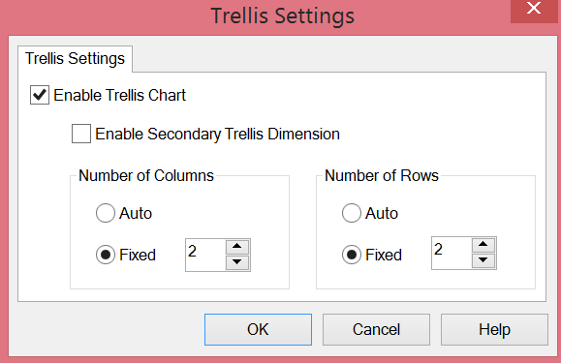

1. Maintain Expressions
   1. Add field 15-19 in expressions
      1. Select field as 15-19
      2. Aggregation -> Average
      3. Click on Paste
      4. Click Ok
      5. Label -> 15-19
   2. Add Field 20-24 in expressions by clicking on the add button in expressions tab
      1. Select field as 20-24
      2. Repeat steps ii. Through iv under a
      3. Label -> 20-24
   3. Add Field 25-29 in expressions by clicking on the add button in expressions tab
      1. Select field as 25-29
      2. Repeat steps ii. Through iv under a
      3. Label -> 25-29

Your screen should look as below:

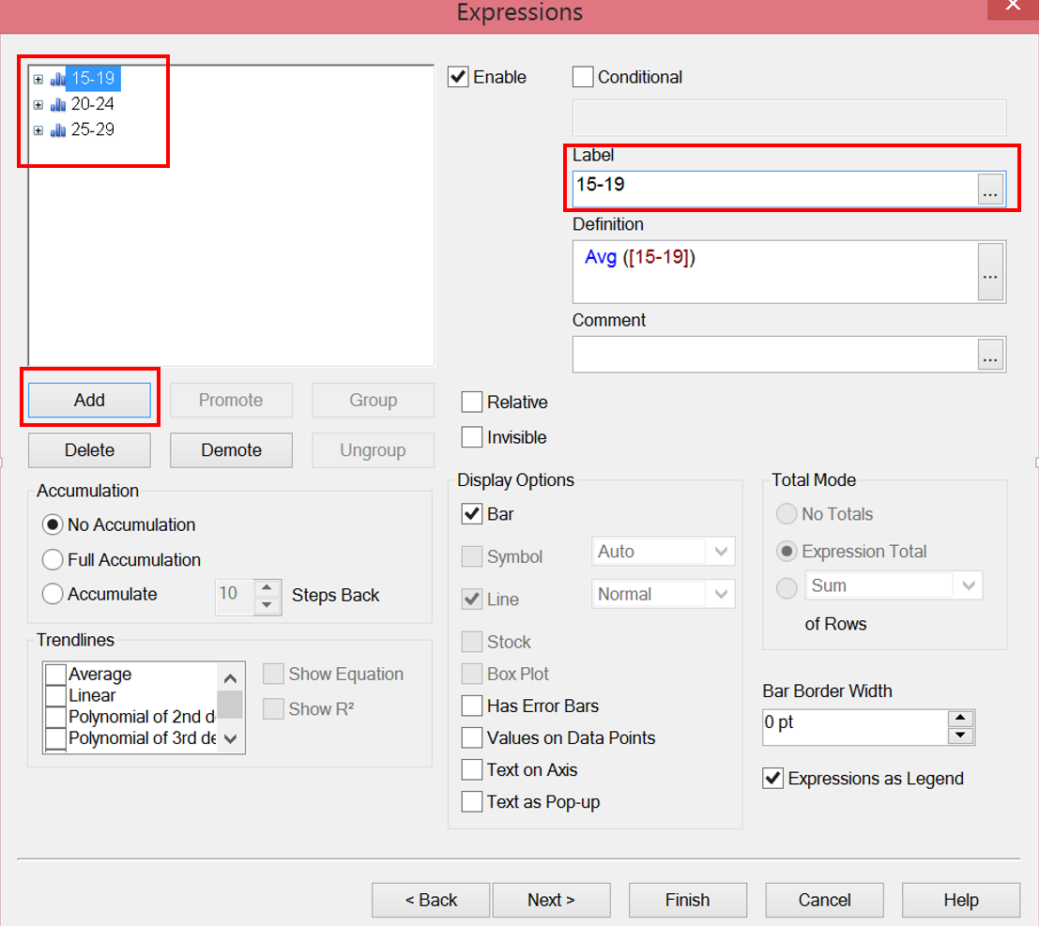

1. Keep clicking next until you reach the last tab, Caption Tab
   1. Uncheck the **Show Caption** checkbox
2. In order to restrict the chart to countries having higher youth income, right click on the chart and select properties
   1. Go to **Dimension Limits** Tab
      1. Select Geographies
         1. Under **Limits**,
            1. Check the checkbox “Restrict which values are displayed using the first expression”
            2. Select Show Only radio button
            3. Select Largest from the drop down values and enter 10 in the text box.
         2. Under **Options** section
            1. Uncheck **show others** checkbox

Screen should look as below:

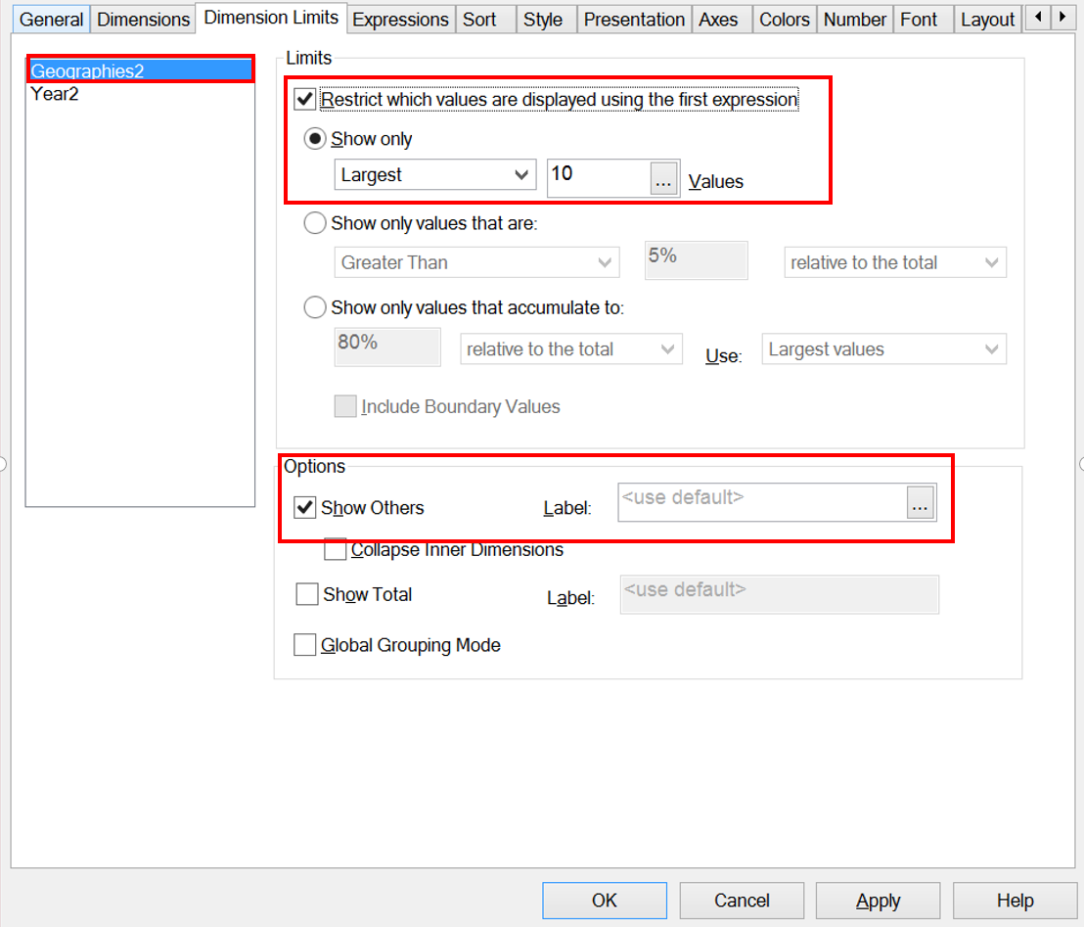

1. Click Apply and then click Ok.

**Note**: Expand the chart to view the data against different countries properly

**Step 2.5: Create Youth Gross Income Trend**

1. Right click anywhere in a blank area of the Youth Gross Income Sheet.
   1. Select New Sheet Object -> Chart
2. In General tab, maintain chart title as **Student Name: Youth Income Trend** and select the chart type as **Line chart** and then click next
3. Maintain the following dimensions under **dimensions tab**
   1. Add dimension Geographies2
      1. Maintain Label as Geographies
      2. Check Suppress when value is null checkbox
   2. Add dimension Year2
      1. Maintain Label as Year
      2. Check Suppress when value is null checkbox
4. Click on **Animate** button (Bottom Left) under dimensions tab, a popup will appear. Maintain the settings as highlighted in the screenshot.

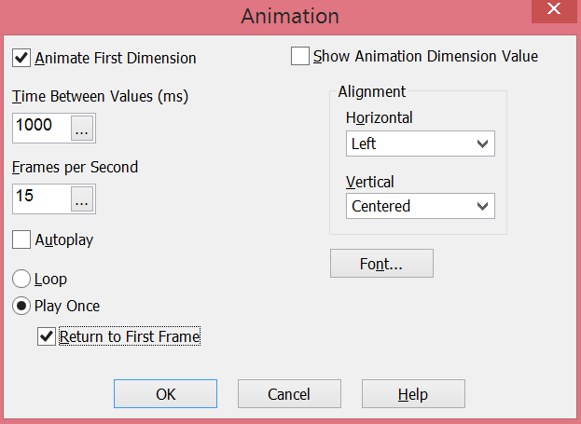

1. Click next & maintain the expressions under **expressions tab** exactly the way in point 5 in step 1.5.Output should look as below

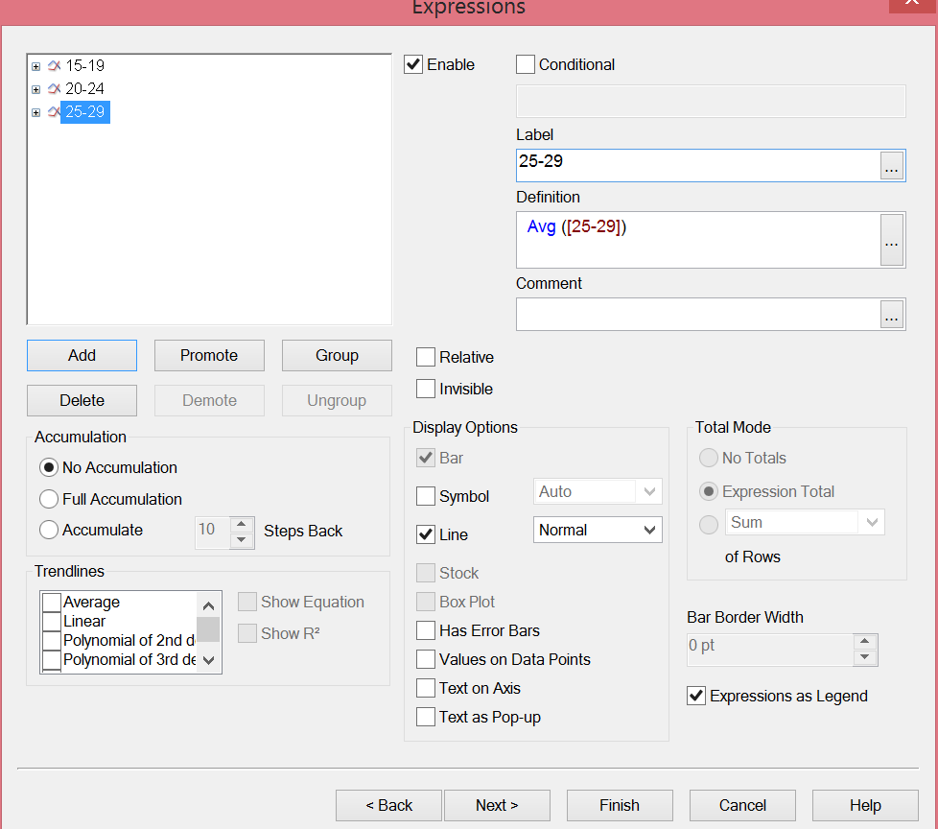

1. Keep clicking on next until you reach the last tab i.e. the **caption** **tab**
   1. Uncheck “**Show Caption**” checkbox
2. Click Finish
3. In order to filter the data, right click on the line graph, select properties
   * 1. Under Dimension Limits Tab, select **Geographies** dimension
        1. Under Limits Section
           1. Check **Restrict which values are displayed using the first expression** checkbox
           2. Select **Show only** radio button
           3. Select **Largest** from the drop down value
           4. Enter **15** in the text box
        2. Uncheck **Show Others** under Options section

Your screen should look as below:-

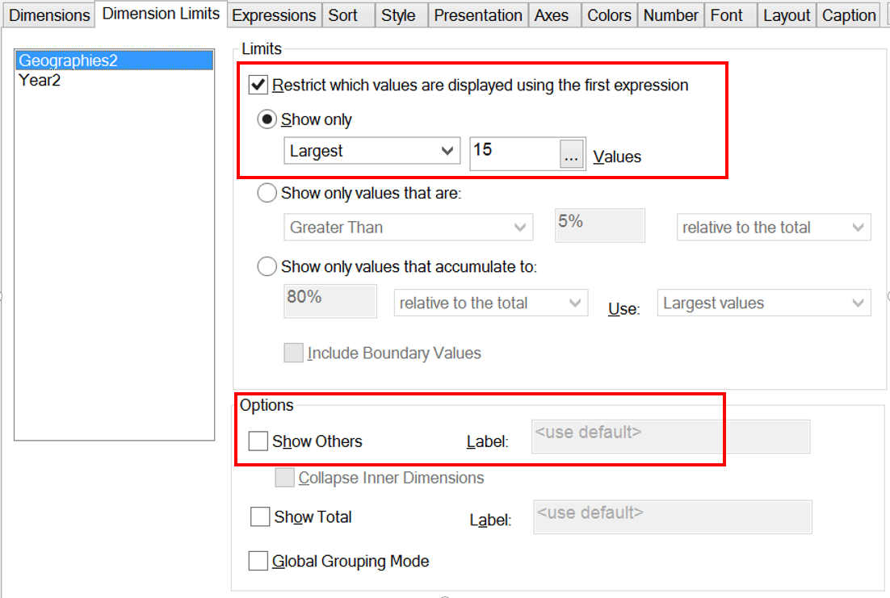

1. Click Apply & then click Ok. Expand the graph to view the data properly
2. Please note that the animation is based on geographies as highlighted in red. As you click on the play button under blue box the geographies would change



1. Save the QlikView file

**Step 2.6: Add Filter for Year**

**Note:** Maintain field as **Year2**

Please refer to **section 1.7** under **Youth Employment Population**

**Step 2.7: Save the QlikView File**

**Questions:**

* 1. Paste the screenshot of your sheet

**Answer**

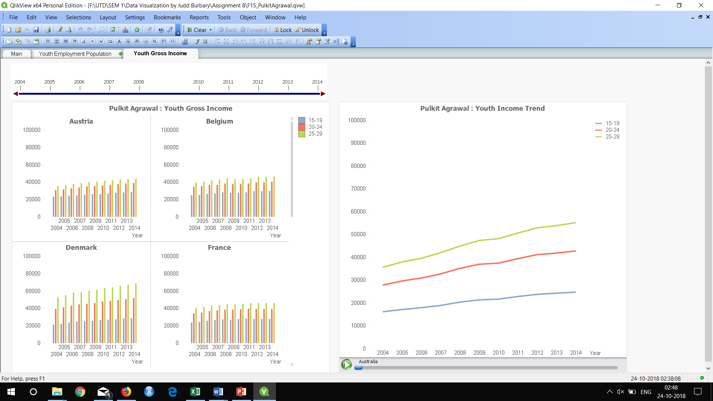

* 1. In which year was there a dip in the youth income in United Arab Emirates across all categories?

**Answer 2009**

1. **Visualize Youth Expenditure by Age Category**

**Step 3: Create Charts for Youth Expenditure**

**Step 3.1: Add Youth Expenditure Data set to QlikView file**

**Note:** We need to follow the same steps highlighted in **step 1** under **Youth Employment Population.**

1. Go to File Menu -> Edit Script
2. Under Data tab, click on table files
3. Select the downloaded **Youth Expenditure** data set, then click open
4. Maintain the Labels as **Embedded Labels (As highlighted in red),** click next

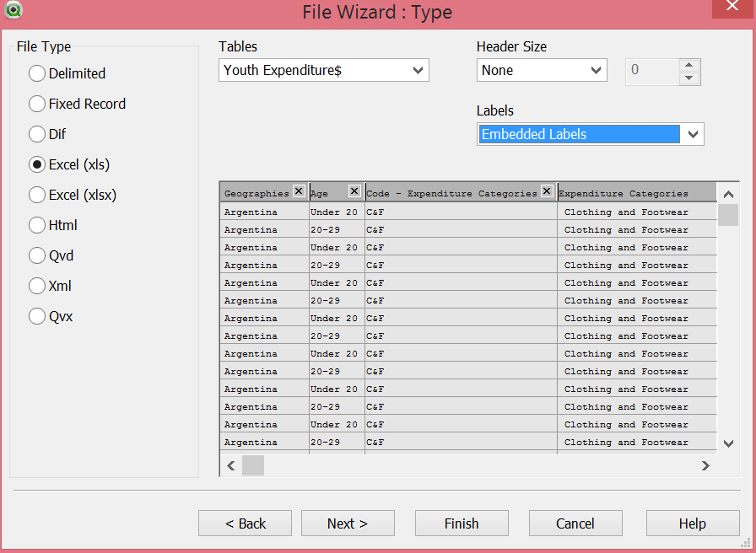

1. Click **next** three times and then click **finish**
2. Rename the fields in the tables as highlighted below.

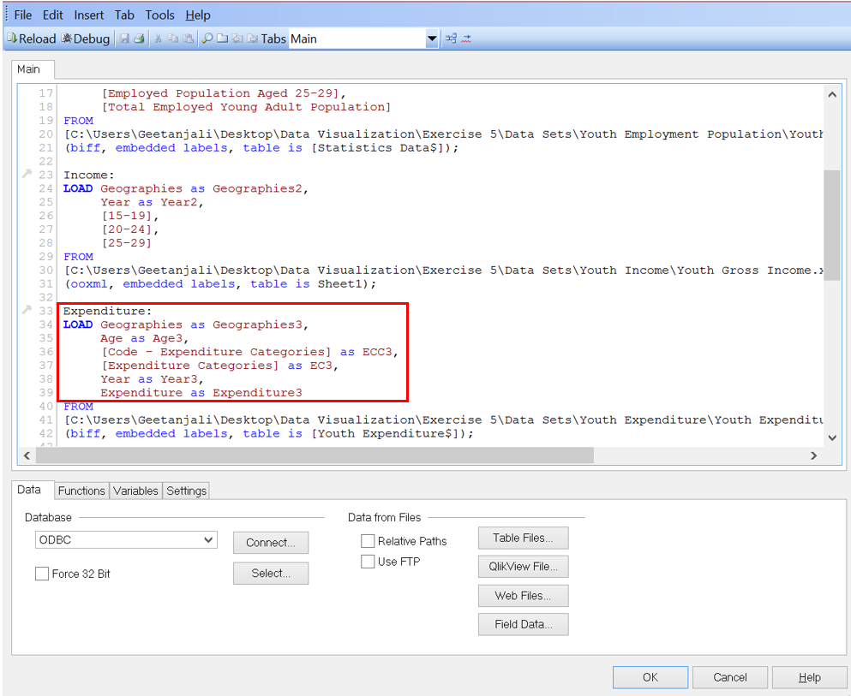

1. Click Ok 2 times. At this stage the data set available in the QlikView.
2. Click on Reload button in order to make the data of the uploaded file available in QlikView. For more details refer to **section 1.2** under **youth employment population**

**Step 3.2: Create a New Sheet**

Follow the steps as highlighted in **step 1.4** under **youth employment population** to add a new sheet and rename it as **Per Capita Youth Expenditure**

**Step 3.3: Create Multi / Trellis Chart to display Per capita Youth Expenditure**

1. Create a filter for field **Geographies3** by clicking on create list box button. Refer to **section** **1.5** under **Youth Employment Population** for details.
2. Right click anywhere inside **Per Capita Youth Expenditure** sheet
   1. Select New Sheet Object -> Chart
3. In General tab, maintain chart title and select the chart type as **Line** chart and then click next

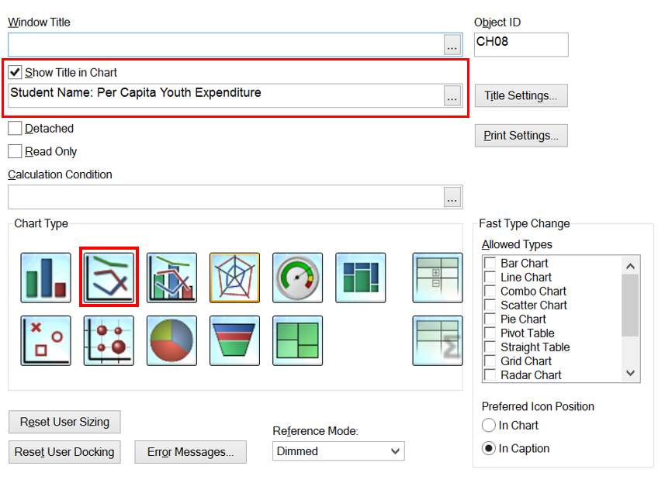

1. Maintain the Dimensions in the Dimensions window and then click next
   1. Add **Geographies3** into **Used Dimensions** section
      1. Check the checkbox “Suppress when value is Null”
      2. Maintain Label as **Geographies**
   2. Add **Year3** into **Used Dimensions** Section
      1. Check the checkbox “Suppress when value is Null”
      2. Maintain Label as **Year**
   3. Add **ECC3** into **Used Dimensions** Section
      1. Check the checkbox “Suppress when value is Null”
      2. Maintain Label as **Expenditure Category Code**
   4. Add **Age3** into **Used Dimensions** Section
      1. Check the checkbox “Suppress when value is Null”
      2. Maintain Label as **Age**
2. Click on Trellis button, a popup appears. Maintain values as highlighted below:-



1. Maintain Expressions
   1. Add field 15-19 in expressions
      1. Select field as **Expenditure3**
      2. Aggregation -> **Average**
      3. Click on Paste
      4. Click Ok
      5. Label -> **Youth Expenditure**

Your screen should look as below:-

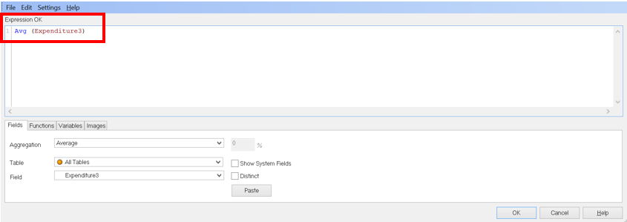

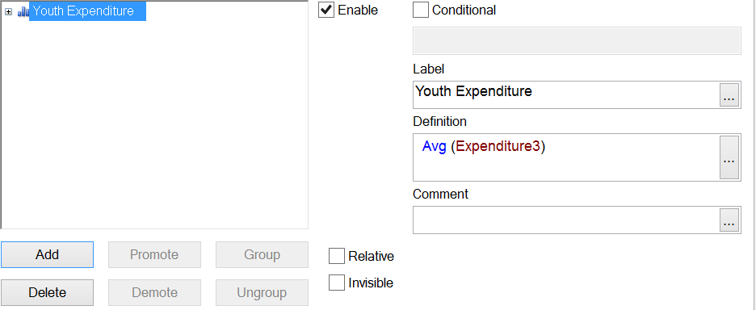

1. Keep clicking next until you reach the last window (Caption Tab)
   1. Uncheck the **Show Caption** checkbox

Click Finish

1. In order to restrict the chart to countries having higher youth income, right click on the chart and select properties
   1. Go to **Dimension Limits** Tab
      1. Select **Geographies3**
         1. Under **Limits**,
            1. Check the checkbox “Restrict which values are displayed using the first expression”
            2. Select Show Only radio button
            3. Select Largest from the drop down values and enter 10 in the text box.
         2. Under **Options** section
            1. Uncheck **show others** checkbox

Your screen should look as below:-

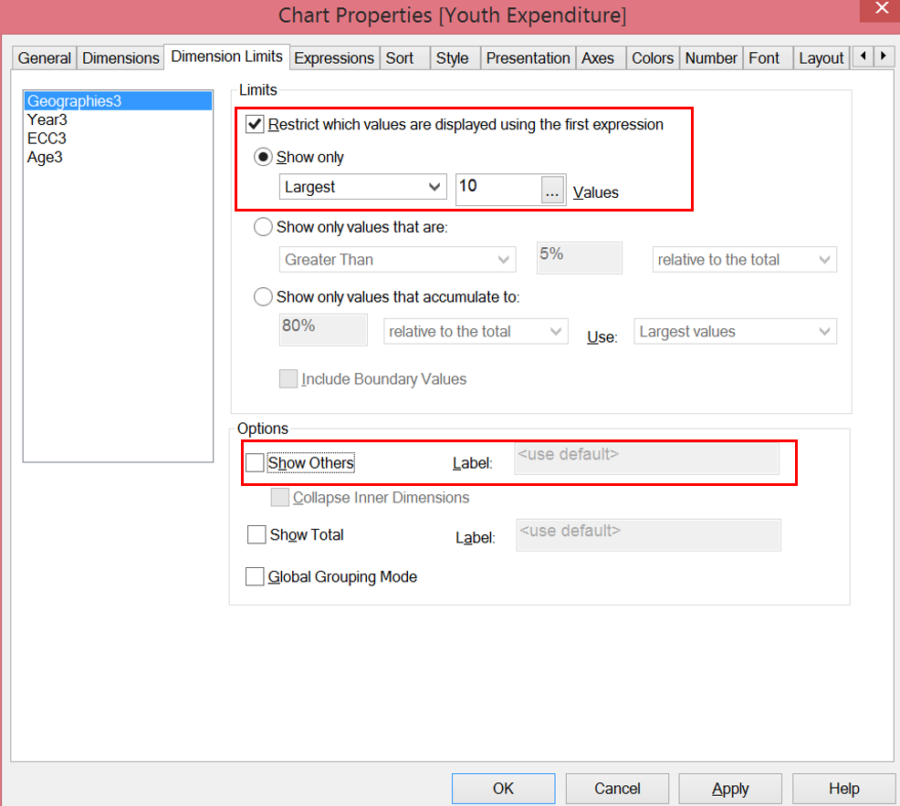

1. Click **Apply** and then click **Ok.** Expand the chart to view the data against different countries properly
2. Save the QlikView file

**Step 3.4: Add Filter for Year**

**Note:** Maintain field as **Year3**

Please refer to **section 1.7** under **youth employment population**

**Step 3.5: Create List box for Expenditure Categories to filter Categories**

Click on the **Create List Box** icon as highlight below from the toolbar.

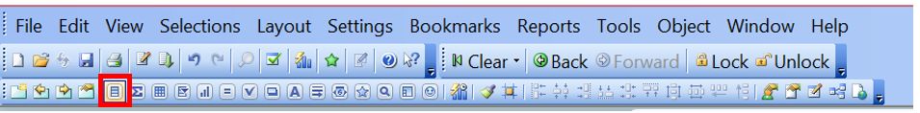

Following popup appears, maintain the following in the general tab:-

1. **Title**: Exp. Categories
2. **Field**: EC3

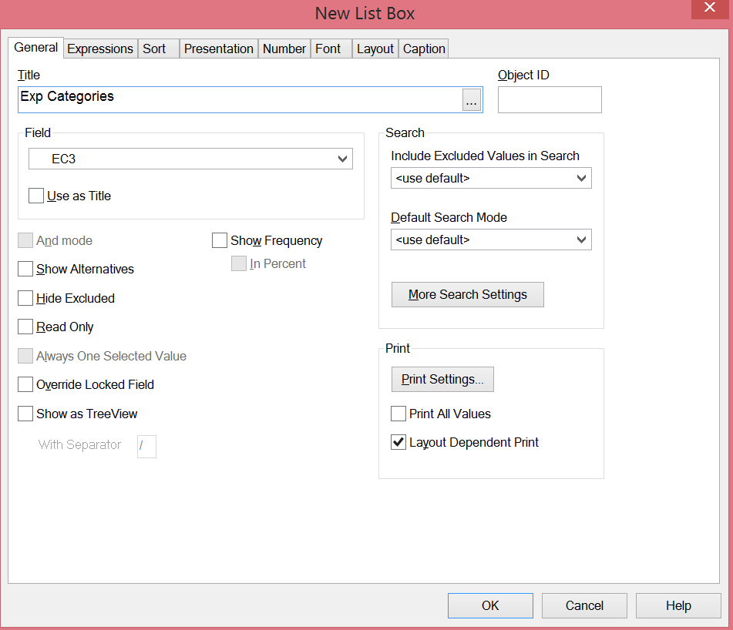

Click on **Ok.**

Adjust the graphs and shift the list box to the right side of the sheet. You can select or deselect multiple entries by clicking on control button.

**Step 3.6: Save the QlikView File**

**Questions:**

* 1. Paste the screenshot of your sheet

Answer:

* 1. On Which commodity does the youth spend the most?

Answer:

* 1. On which commodity does the youth in Switzerland spend the most in the year 2007?

Answer:

1. **Visualize Youth Expenditure without Age Categories**

**Step 4: Create Chart for Aggregated Youth Expenditure**

**Step 4.1: Add Youth Expenditure without age split Data set to QlikView file**

**Note:** We need to follow the same steps highlighted in **step 1 under youth employment population.**

1. Go to File Menu -> Edit Script
2. Under Data tab, click on table files
3. Select the downloaded **Youth Expenditure** **Without age split** data set, then click open
4. Maintain the Labels as **Embedded Labels (As highlighted in red),** click next

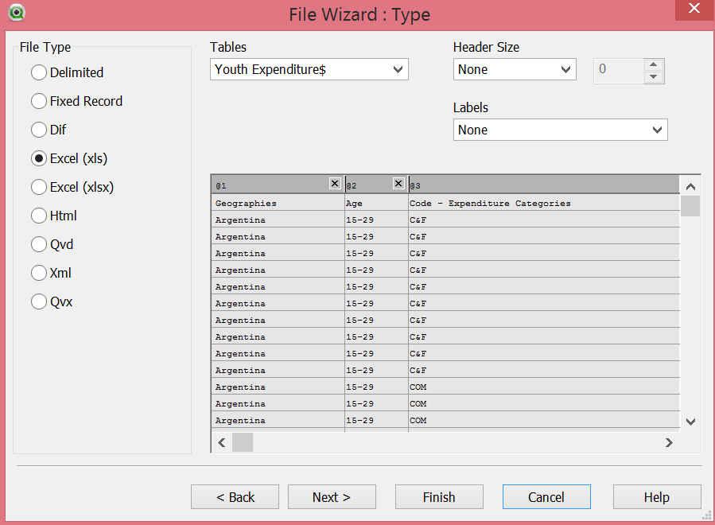

1. Click **next** thrice and then click **finish**
2. Add data set Youth Employment Population excel by repeating steps 2-5

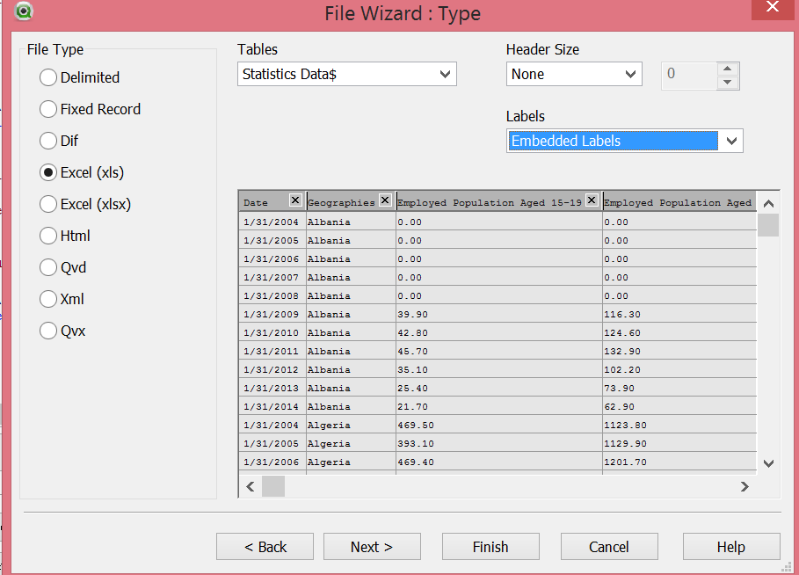

1. Rename the fields in both the tables as highlighted below. In this sheet we need to calculate the **aggregated youth expenditure** so we need to **join** (Left Join) the **Youth expenditure table** with the **Youth Employment Population table** as highlighted below in red.

**Note**: For this sheet field names starts with alphabet ‘**E’**

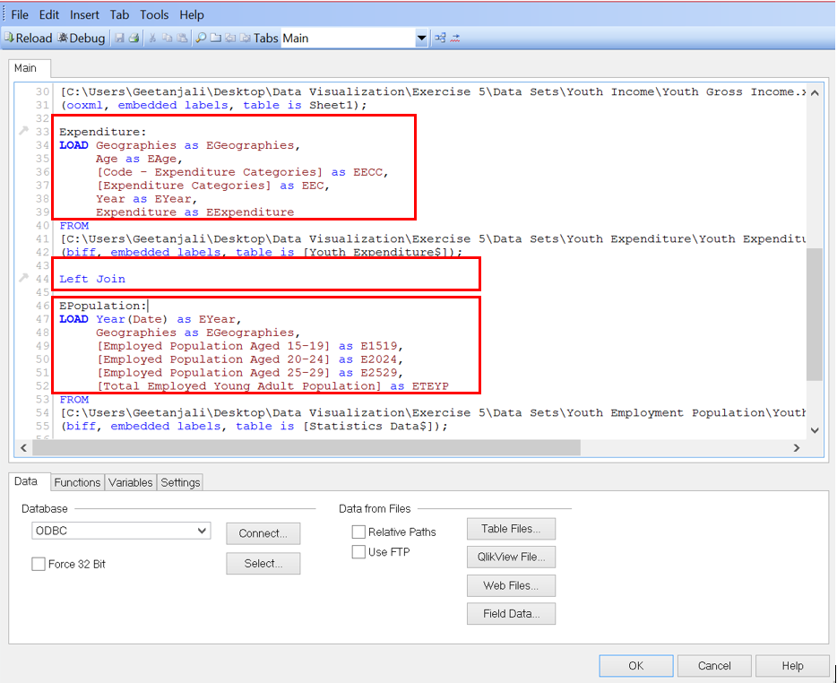

1. Click Ok twice. At this stage the data set available in the QlikView.
2. Save QlikView file by clicking on the save button in the edit script window.
3. Click on reload button in order to make the Youth Expenditure data available in QlikView. Refer to **section 1.2** under **Youth Employment Population** for details.

**Step 4.2: Create a New Sheet**

Follow the steps as highlighted in **step 1.4 under youth employment population** to add a new sheet and rename the new sheet as **Aggregated Youth Expenditure**

**Step 4.3: Create Bar Chart to display Aggregated Youth Expenditure**

1. Create a filter on field **EGeographies** by creating a list box

Refer to **Step 1.5** under **Youth Employment Population**

1. Right click anywhere inside **Aggregated Youth Expenditure** sheet
   1. Select New Sheet Object -> Chart
2. In General tab, maintain chart title and select the chart type as **Bar chart** and then click next

Title: **Student Name: Aggregated Youth Expenditure**

1. Maintain the Dimensions in the Dimensions Tab and then click next
   1. Add **EGeographies** into **Used Dimensions** section
      1. Check the checkbox “Suppress when value is Null”
      2. Maintain Label as **Geographies**
   2. Add **EYear** (Year under Expenditure) into **Used Dimensions** Section
      1. Check the checkbox “Suppress when value is Null”
      2. Maintain Label as **Year**
   3. Add **EECC** into **Used Dimensions** Section
      1. Check the checkbox “Suppress when value is Null”
      2. Maintain Label as **Expenditure Category Code**
2. Maintain Expressions

**Total Youth Expenditure** = **Total Youth Population** (**15-19, 20-24, 25-29 Age Groups**) Multiplied by Youth Expenditure

**Formula:** ([E1519] + [E2024] + [E2529]) * EExpenditure

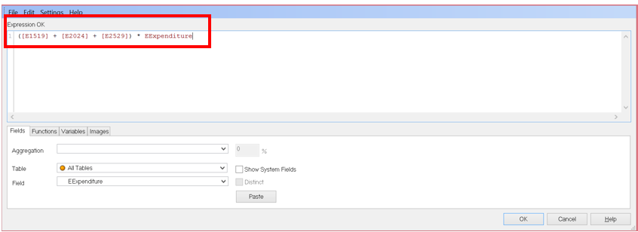

**Expression Label: -** Aggregated Expenditure

1. Keep clicking next until you reach the last tab, Caption Tab
   1. Uncheck the **Show Caption** checkbox

Click Finish

Note: If you don’t see any data in the graph, ensure data is loaded properly and select any geographic location/ column in the table

1. In order to restrict the chart to countries having higher youth income, right click on the chart and select properties
   1. Go to **Dimension Limits** Tab
      1. Select Geographies
         1. Under **Limits**,
            1. Check the checkbox “Restrict which values are displayed using the first expression”
            2. Select Show Only radio button
            3. Select Largest from the drop down values and enter 10 in the text box.
         2. Under **Options** section
            1. Uncheck **show others** checkbox
2. Under Sort Tab, Maintain following values highlighted in red

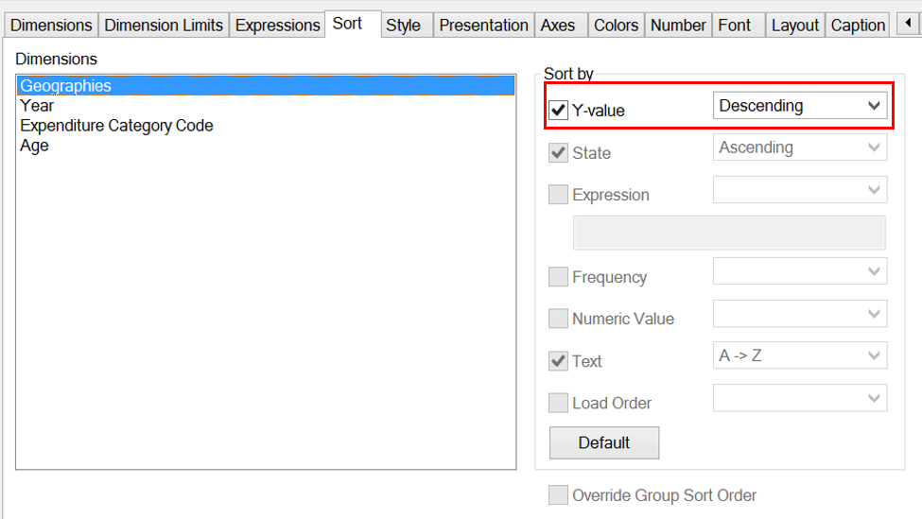

1. Click **Apply** and then click **Ok.** Expand the chart to view the data against different countries properly

**Step 4.4: Add Filter for Year**

**Note:** Maintain Field as **EYear**

Please refer to **section 1.7 under Youth Employment Population**

**Step 4.5: Create List box for Expenditure Categories to filter Categories**

**Note:** Maintain Field as **EECC**

Please refer to **section 1.7 under Youth Expenditure by Age Category**

**Questions:**

* 1. Paste the screenshot of your sheet

Answer:

* 1. In which year did the youth spend on housing the most in Switzerland?

Answer:

* 1. In which year(s) do you see sudden dip in the youth expenditure in Ukraine?

Answer:

**Note:** Once all the above steps are created, please delete the sheet named Main in the QlikView file.

Save the QlikView file

**Upload both the QlikView file along with the assignment Document (solutions only) in the eLearning**